

 WINCURVE
SOFTWARE User’s guide

CAMECA IMS 7f / 4f-E7
CAMECA IMS Wf / SC-Ultra

45 610 687 – 108 - B
Cameca SIMS data processing index

Version: 1.89

The CAMECA SIMS Software user’s guide
WinCurve 1.89
00 45 610 687 - Type 108 – Indice B
0000.doc
Contents
1. Introduction to WinCurve 5
1.1. WinCurve Workspace 5
1.1.1. Using Menus, Toolbars, Status Bar 6
1.1.2. Docking Panels 8
1.1.3. Graph Window 12
1.1.4. Curve 12
1.1.5. Layout 13
1.2. Files and Data Format 13
1.2.1. File Type 13
1.2.2. Analysis Type 13
2. WinCurve Basics 15
2.1. WinCurve Menus 15
2.1.1. File Menu 15
2.1.2. Edit Menu 18
2.1.3. View Menu 20
2.1.4. Window Menu 21
2.1.5. Layout Menu 22
2.1.6. Help Menu 23
2.2. ToolBars 24
2.2.1. Standard Toolbar 24
2.2.2. Split Graph Toolbar 24
2.2.3. Graph Toolbar 26
2.2.4. Trace Lines Toolbar 31
2.3. Snap Acquisition 31
2.4. Species Panel 33
2.5. Graph Window Control 35
2.5.1. Axes Options and Background Panel 35
2.5.2. Curve Options Panel 37
2.5.3. Units Panel 38
2.5.4. Labels Panel 39
2.5.5. Application Options Panel 41
2.6. Presentation and Data Management 42
2.6.1. Table Panel 42
2.6.2. Comments Panel 43
2.6.3. Analytical Conditions Panel 46
2.6.4. Data Summary Panel 47
2.6.5. Word Report Generation 48
2.6.6. ASCII Data Panel 51
2.6.7. Copy Curves Panel 52
2.6.8. Delete Curves Panel 53
2.7. Compatibility with the CAMECA UNIX Based Curve Program 54
3. Depth Calibration 55
3.1. Copy Function for Depth Calibration 57
3.2. Depth Curve 58
3.3. Crater Mode 59
3.4. Depth Mode 59
3.5. Thickness Mode 60
3.6. SR Known Mode 60
3.7. SR Point Normalization Mode 62
3.8. SR Normalization Mode 64
3.9. In-situ Mode with the Sputter Rate Correction 66
3.10. Depth Curve Mode 68
3.11. Multilayer Depth Calibration 68
4. Concentration Calibration 71
4.1. Reference Signal 73
4.2. Copy Function for Concentration Calibration 74
4.3. RSF Method 75
4.4. Concentration Method 77
4.5. Dose Method 79
4.6. Multilayer Concentration Calibration 80
5. Processing Panel 80
5.1. History 83
5.2. Normalization 85
5.2.1. Ip Normalization 85
5.2.2. Reference Signal Normalization 86
5.2.3. Reference Element Normalization 87
5.2.4. 100% Normalization 89
5.3. Scaling 90
5.4. Background Subtractions 91
5.5. Statistics 92
5.6. Smoothing 93
5.7. Linear Combination 94
5.8. Data Points Removal 95
5.9. Derivative 97
5.10. Integration 98
5.11. Interpolation 99
5.12. Fitting 100
5.13. Decay X 102
5.14. Layer Width 103
5.15. Peak Width 103
5.16. X Shift 104
5.17. Abundance Sensibility 105
6. Batch Processing Panel 105
6.1. Recipe File 106
6.2. Preparing Batch Execution 106
6.3. Batch Execution 107
6.4. Report Generation during Batch Processing 110
6.4.1. Batch Processing Log 110
6.4.2. Batch Processing Data Summary Report 111
7. Data Base Panel 112
7.1. Database Entry 112
7.1.1. Sputter Rate Part of Database 112
7.1.2. RSF Part of Database 114
7.1.3. Reference Sample Database 115
7.2. SR/RSF Database Query 117
7.3. Reference Sample Database Query 122
8. Utilities 123
8.1. Table of the File Types 123
8.2. Shortcuts 124

Introduction to WinCurve
WinCurve is a Windows™-based program which enables the user to process data obtained on CAMECA IMS instruments:
- magnetic sector: from IMS 3F/4F (equipped with SUN workstation), IMS 5F/6F up to the latest IMS 7F and SC-Ultra / Wf secondary ion mass spectrometers
- quadrupole QUAD 4550/4600.

WinCurve Workspace
The term Workspace describes the user interface that you see when you first load the program. The particularity of WinCurve is the grouping of a significant amount of information in a fixed area. The Workspace has four principal areas:
  - Command area is placed at the top of the Workspace. It contains the title bar which displays the file path of the current document. Below that is the menu bar, which contains standard Windows commands plus WinCurve menus. Below the menus are toolbars that provide one-click access to commands and WinCurve tools.
  - Graph window displays the Curves from the loaded file, as well as the processed Curves. The Graph windows are located at the center of the Workspace in the Graph area.
  - Docking panels are used for the data sources management, the Data processing and the Graph window control. Panels in WinCurve are grouped together into stacked panel groups. Each panel within a panel group appears as a tab. By default, panel groups are docked to allow easy access to the panel you need without cluttering your Workspace.
  - Status bar at the bottom of the Workspace provides additional information.

The following illustration shows the main Workspace areas:

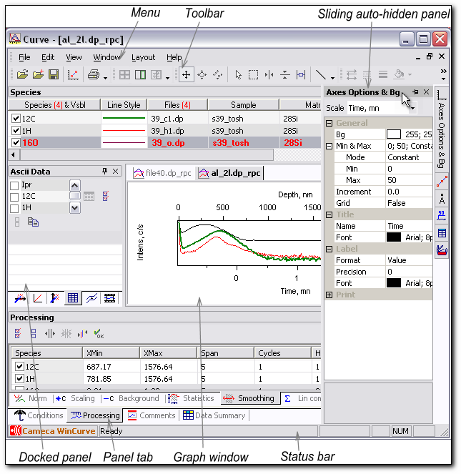
Figure 1. WinCurve Workspace.
Contents

Using Menus, Toolbars, Status Bar
♦ Menus. The menus are found along the top edge of the Workspace area. Several menu commands have corresponding toolbar buttons and keyboard shortcuts. To execute a menu command, choose it from the menu with the mouse cursor, click its corresponding toolbar button (if it has one) or press its keyboard shortcut.
The menu includes the following options: File, Edit, View, Window, Layout and Help. If a keyboard shortcut is available for the menu command it is shown to the right side of the menu item. If corresponding toolbar button or panel tab icon exists, then it is shown to the left side of the menu item. The small black arrow to the right of menu item indicates that a submenu for that item exists. Clicking the menu item or holding a mouse over that item makes menu appear. Not all menu commands are available all the time. The dimmed menu commands are unavailable.
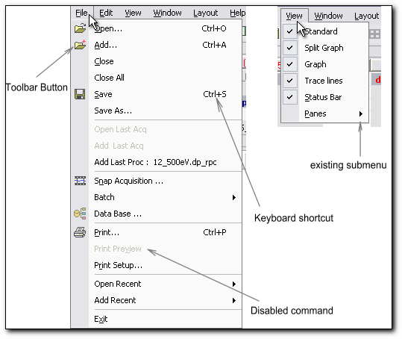
Figure 2. Menu features.
♦Toolbars. WinCurve includes four toolbars that provide single-click access to the commands. These are docking toolbars. They may float independently or be docked to the Workspace edges. By default, all four toolbars are visible and docked to the top of the Workspace.
You can make any docked toolbar a floating toolbar by clicking and dragging it away from the Workspace edge. When the toolbar becomes floating you can resize it by dragging its edges. You can then drag and dock it in at any Workspace edge or double-click on the toolbar title bar to automatically dock it to its last location. All toolbar buttons have tool-tips. If you hold the mouse over a toolbar button, a tool-tip appears. This feature is useful for identifying buttons.
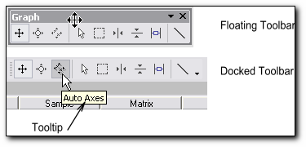
Figure 3. Floating and Docked toolbars.
♦Status bar is placed along the bottom of the Workspace. The status bar can not be pulled away from the Workspace edge. It hints at the action of the feature over which the mouse is currently located.
Contents

Docking Panels
WinCurve works with docking panels. Each panel has a title. It is always seen when the panel is visible. A panel may be docked, auto-hidden (sliding) or floating (undocked). Auto-hidden and docked panels have two buttons on the upper right-hand corner. The first button is a pushpin button. It is used to switch between docked and auto-hide mode. The second button is the close button. It is used to close the panel.
Panels may be grouped together with tabs. Tabs appear at the bottom or on the side of the panel group. Panels are docked by default within the program window. A particular task may be easier if you float a panel. A panel can be moved inside and outside the WinCurve program's frame window to any location of the monitor.
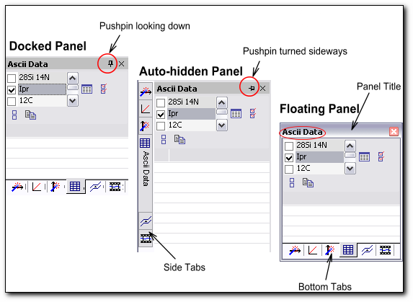
Figure 4. Docked, auto-hide, and floating panels.
Contents

Float and Dock Panels
You can easily float your docked panel or dock your floating panel at any docking area of your Workspace.
To float a docked panel:
- Place cursor on the title bar, press it and drag the panel into the desirable position.
- Release cursor.

 To move a panel without snapping it into place, press CTRL while dragging it across the monitor screen.
To dock a floating panel:
- Place cursor on the title bar, press it and drag the panel into the desirable position.
- A grey outline appears.
- Release cursor.
To auto-hide a docked panel:
- Select pushpin on the title bar.
- Place cursor on desired tab of the tabbar; the panel slides.
- Place cursor anywhere outside the panel and the panel disappears.
To slide an auto-hidden panel:
- Place cursor on desired tab of the tabbar; the panel slides.
- Select the title bar; the panel freezes.
- Place cursor anywhere outside the panel and press it, the panel disappears.

Contents

Dragging Panel Position
The WinCurve program gives you the flexibility of drag and drop positioning. You can easily drag and drop any docking panel or tab onto any docking area within your Workspace. You can also drag any floating panel anywhere on the monitor.
 You can not move an auto-hidden panel.
To move a panel:
- Place the cursor anywhere on the panel's title bar, hold down the left mouse button, and start moving the panel. A gray outline appears around the panel.
If you use the title bar to move the tabbed panels, then all panels in the stack move. To move one of the panels out of the stack, drag the tab of the panel you want to move.
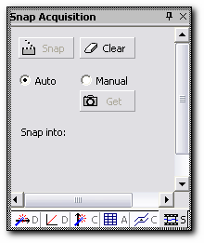
Figure 5. A gray outline appears around the panel to be moved.
- Drag the outline to the new location. The outline size may change as you drag it. When the cursor is over the title bar of a panel, the outline fills the panel. When you place your cursor over a tab in a stack of panels, the outline also fills the panel:
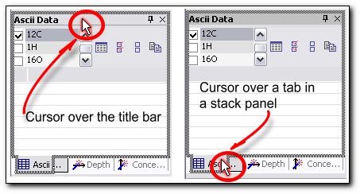

As you drag the cursor toward any border, the outline becomes a narrow rectangle adjacent to that border:
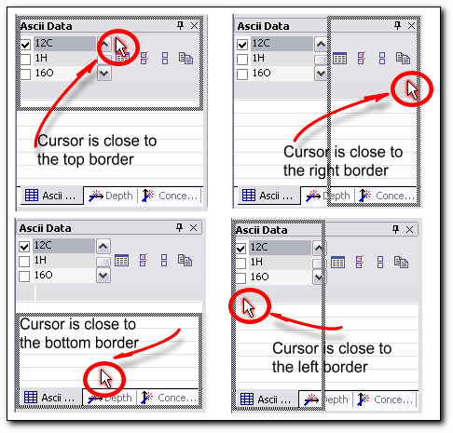
Figure 6. A grey outline which marks the new place for the panel.

- You can drag the outline to any place of your monitor, but if you do so and drag your panel to an undocking area, your panel becomes floating.
- Release the mouse button to drop the panel in the location.
Double click on the title bar of the panel to restore that panel at its previous location.

To resize a panel drag the splitter bars between panels.

Contents

Grouping Panels
You can group panels in a tab arrangement and display them docked to any side of your Workspace. The docking panels can be grouped together or docked inside one another to make the best use of available Workspace.
You can create detachable, tabbed docking panels that you can place along any side of your Workspace. These tabbed panels allow you to drag and "tear off" any of the individual tabs to create new panels that can either float or dock to the side of your Workspace. You can also drag and drop panels to an existing panel in order to create a tabbed panel. You can rearrange the order of tabs within a tabbed panel. An outline is drawn to depict where your window will be located when you tear off or combine panels.
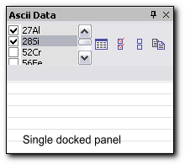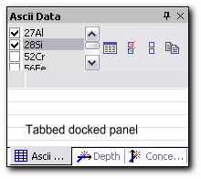
Figure 7. Single and tabbed docked panels.
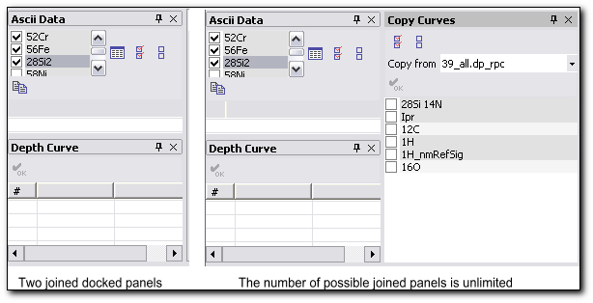
Figure 8. Joined docking panels.
Contents

Hide and Show Panels
WinCurve allows you to easily hide and show panels to optimize your WinCurve Workspace. You can hide your docked or floating panels quickly by pressing the small ‘x’ located in the upper right-hand corner of the title bar. You can also easily display and activate your panels through your View Menu or the keyboard shortcuts.
You may want to add additional panels to the Workspace. If there are any panels you rarely use, you can move them into an overlapped stack or close them.
To add a new panel to the Workspace:
  - Select the panel you want to add from the View Menu.
The new panel displays on top of the existing stack.
To remove a panel from the Workspace:
  - Display the panel's title bar if it is not already visible by choosing panel’s tab and click the Close button.
Auto-Hidden panels provide a unique way for you to make the most of your Workspace by hiding or showing panels with simple mouse movements.
For the floating panel: you can move, resize and close panel window with the pop-up menu which appears when you right-click your mouse on the panel title bar. In this case, you can also use a keyboard for moving and resizing.

Contents

Graph Window
The Graph window is a movable, resizable window for displaying, analyzing and organizing your work. The Graph window is not a docking window. It can only be moved within the Graph area. The main purpose of the Graph window is to plot a raw data set and a processed data set. The Graph windows can be located in the Graph area in the center of Workspace, this area is surrounded by docked panels.
Each opened file is associated with one Graph window. Each Graph window may contain: Curves, Axes, Labels and Lines. You may split the Graph window into two or, in several cases, into many parts.
Contents

Curve
A Curve consists of a set of data points. There are six types of Curves:
  - Depth Profile
  - Mass Spectrum
  - High Resolution
  - Bar Graph
  - Energy Spectrum
  - Line Scan
The Curve may be a raw data Curve or a processed Curve.
The WinCurve program works with the concept of a current Curve. Only one Curve may be a current Curve at any given time. A Curve has to have the visible status and be selected on the Species panel in order to act as a current Curve. A Curve can also become the current Curve by double-clicking on the desired Curve in the Graph window. A current Curve is drawn in white; on a white background, it is drawn in black. A Graph window which contains the current Curve is a current Graph window.
The general rules for Curve handling are:
  - Only Curves of the same analysis type (depth profile, line scan…) files can be loaded together in the same Graph window.
  - The number of Curves is quasi-unlimited.
  - Curves with the visible status are loaded in the Graph window.
  - Curves from different files can be loaded into the same Graph window.
Contents

Layout
A Layout consists of a preconfigured set of panels, Graph area and Toolbars, their sizes, positions and states.
To make the most efficient use of your Workspace, WinCurve supports default and customized positions of panel groups. The Workspace is set by default, but you can also manipulate this Workspace to suit your needs. To customize it, you can move a tab from one panel group to another, or you can separate a tab and create a new stand-alone panel, set several panels into auto-hide mode, maximize the Graph area, move toolbars etc. You may save and rename your layout for later use.
Contents

Files and Data Format

File Type
The WinCurve program can handle two file types:
- Raw data files, binary format. A file contains one or several Curves plus all Analytical Conditions used to run the analysis.
- Processed data files, binary format.
  - Raw data files
A file name is always built with an extension characteristic of the analysis type: filename.analysis type. The overwriting of these files is not permitted by the WinCurve program. Raw data stored on the disk cannot be modified by the operator. It contains Curves corresponding to one analysis only. On effort to modify a raw data file, a new processed data file with an extension analysis type_rpc appears.
  - Processed data files
The file name always has the extension analysis type_rpc. These files can be overwritten. They may contain Curves of the same type coming from different raw data files.
A processed file may be the combination of several source files.

Contents

Analysis Type
A raw data file name consists of a string of characters freely defined by the operator as well as an extension which characterizes the analysis type. There are six analysis types which can be performed on the Cameca IMS instruments:
Depth profile file_name.dp
Line scan file_name.ls
Mass spectrum file_name.ms
High resolution file_name.hr
Bar graph file_name.br
Energy file_name.nrj

Every analysis type in WinCurve has its own icon in the Graph window, which appears to the left of the file name. Examples of the Graph windows for the different analysis types are shown below:

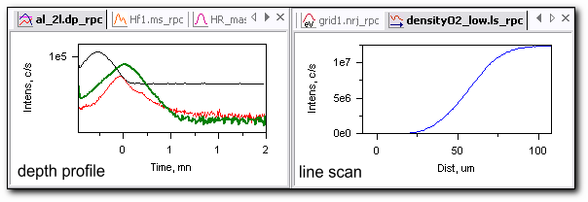
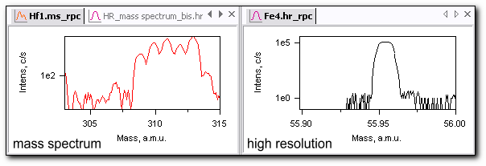
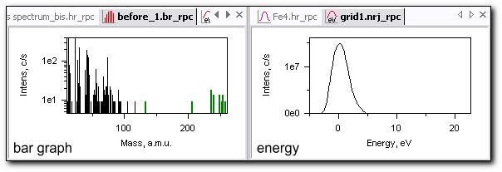
Figure 9. Examples of the Graph windows with all possible analysis type data.
Contents

WinCurve Basics

WinCurve Menus
The WinCurve menu provides commands to perform general operations such as opening a file, arranging the windows or accessing the different areas of the Workspace. Some menu commands have associated keyboard shortcuts. If available, the keyboard shortcut is displayed to the right of the menu command. Some menu commands also have icons that are displayed to the left of the command. The icon indicates that the menu command also has a toolbar button access.

File Menu
The File Menu provides an access to the basic file operations, to print options and to the Snap Acquisitions panel, Batch panel, Data Base panel.
- Open… (Ctrl+O)
This menu command opens the ‘Open Data File’ window. You may also perform this command by pressing the ‘Open’ toolbar button or the keyboard shortcut Ctrl+O.
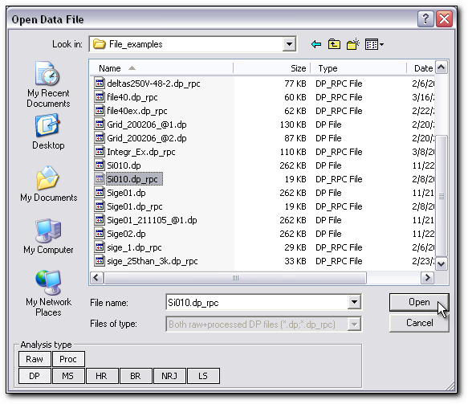
Figure 10. ‘Open Data File’ window.
The ‘Open Data File’ window is a standard file dialog window. On opening, it shows the directory in which the last file choice was effected. The ‘Open Data File’ window has browser properties and can trace changes in the file list. It can open raw data files and processed data files from all Cameca IMS instruments. It is possible to select and open many files at once. To do so, press the Ctrl or Shift key. Two filtering criteria are applied to the file name in order to reduce the file list length:
- Raw/Proc: only names of raw data or processed files are listed.
- Analysis type: (there are six types of analysis) must be selected by clicking the corresponding button; only file names with an extension corresponding to the selected analysis type are listed.
To choose the file criteria press the corresponding buttons in the ‘Analysis type’ box. In the dimmed ‘Files of type’ box you may see the chosen filtering criteria combination. You can open as many data files as you wish.
WinCurve provides another way to open a file. At the bottom of the File Menu there is a list of the last eight files used. You can choose a file to be opened from this list.
You can open the same raw data file several times. In this case you will have several identical Graph windows with the same names. On attempting to save the raw data file, a processed file is created.

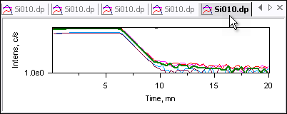
Figure 11. The same raw data file opened in multiple Graph windows.
- Add… (Ctrl+A)
This menu command opens the ‘Add Data File’ window. You may also perform this command by pressing the ‘Add’ toolbar button or the keyboard shortcut Ctrl+A.
You can only append files to the already opened file if they are of the same data type.
- Close
This menu command closes the active Graph window and corresponding file. Should you attempt to perform close it without saving the file, WinCurve opens the ‘Save As’ dialog window, prompting you to choose a path and a file name for this WinCurve file to be closed.
- Close All
This menu command closes all opened Graph windows. If you attempt to Close All without saving the file, a prompt window appears, asking you about saving the unsaved files.
- Save (Ctrl+S)
This menu command saves the current file. Files are saved without any additional prompt. After first opening the program, raw data files are saved into the default proc_spec directory. The directory into which a raw data file is to be saved may be changed after applying the Save As… command to a first file and manually choosing a desired category. All subsequent raw data files will be saved into that directory. Upon attempting to save a raw data file with a corresponding processed file, WinCurve will prompt you to choose another file name and path with the extension dp_rpc.
- Save As…
This menu command opens the ‘Save Data File’ dialog window. This is a standard file dialog window like the ‘Open Data File’ window, except for the fact that instead of the file choice criteria given in the ‘Open Data File’ window, there is only one criterion - a choice between three types of file. The first type is a processed WinCurve file with the extension dp_rpc. The second is a file in the Cameca instruments UNIX ASCII format with the extension dp_rpc_asc. The third file format has the extension dp_rpc_txt, this is an “Excel” type format: another ASCII file with a special tabulation mode. The file formats with the extensions dp_rpc_asc and dp_rpc_txt perform a legacy of previous versions of the Curve program. There is also the possibility to save a file in two formats in the same click: a processed file with the ASCII format or a processed file with the “Excel” type format. The hidden Curves may also be saved by checking the check-box “Save hidden curves”.
An example of the file format with the extension dp_rpc_asc is shown on the figure below.
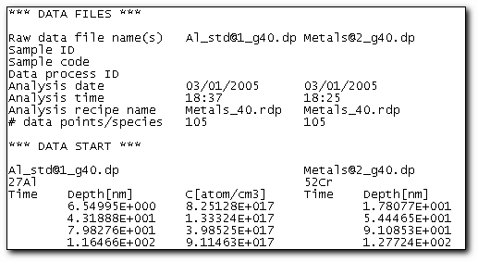
Figure 12. Example of the Unix ASCII data file.
- Open last Acq
This menu command opens the last performed acquisition in a new Graph window.
- Add last Acq
This menu command adds the last performed acquisition to the active Graph window.
- Add last Proc:
This menu command adds the last processed file to the active Graph window.
- Print… (Ctrl+P), Print Setup…
These commands open the standard print dialog window and print the active Graph. This Graph is printed with the applied legend from the Species panel, with the Comments, which are always present, and with the Table if it has been created in the Table panel.
- Open recent
This list contains up to eight recently opened files and may be used for prompted file opening in a new window.
- Add recent
This list also contains up to eight recently opened files but may be used for prompted file addition to the active Graph window.
- Exit
Exit from WinCurve. If you attempt to exit the program without saving the opened files, WinCurve opens the alert box for every file, reminding you to save it.
Contents

Edit Menu
This part of the menu contains commands for copying and pasting of the developed formats, Word templates for the report generation and also contains the stand alone Plot Settings window which defines the global formatting presets for WinCurve.

Copy/Paste Commands
- Copy Graph
This command copies the Graph from the active Graph window to clipboard. Then, the copied Graph can be pasted into any suitable document, for example, into a Word document. By applying this command, not only the Graph itself is copied but also the format applied to this Graph:
  - The copied Curves have the same color as they have in the Graph window except for the current Curve, which has the color shown in the Species panel.
  - The background color is always white.
  - The legend for the Graph together with the Species names is shown.
  - The Axis names and Units are shown.
An example is shown on the figure below:
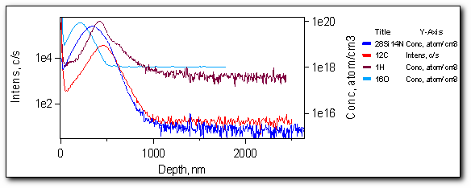
Figure 13. Active Graph, copied to the clipboard.

- Copy Format
Click to copy format settings applied to the active Graph window. The function copies the following format settings:
  - Curve options. If the target window has more Curves then the source window, the Curve’s options for the additional Curves are not changed.
  - Axis and background format; the additional Axes, if existing. If the target window has an Axis other than the source window, the options for this Axis are not changed.
  - Measurement Units. If the target window has an Axis other than the source window, the Units for this Axis are not changed.
  - Labels which have ‘Free’ status.
  - Labels with ‘Hooked’ status. These labels are copied only if a Curve with the same name exists in the target window.
- Paste Format
If there are any saved format settings, then the command becomes undimmed and the file name, from which the settings will apply, is shown. Press the command to apply the saved format settings to the active Graph window.
Contents

Plot Settings Window.
The Plot Settings window defines the global plotting presets for the whole WinCurve program. This is an always-on-top window and is not a docking window. The Plot Settings window can also be opened by pressing the corresponding toolbar button.
You can define all graphical presets for Curves, Axes, Background and measurement Units there. You can apply the changed presets immediately to all opened Graph windows by selecting the ‘Apply to Opened graphs’ check box. Otherwise, the new presets will apply only to the Graph windows opened from raw data files after changing the presets. However, it is possible to customize the active Graph window through the Axes Options & Bg panel , the Units panel and the Curve Options panel.
The Plot Settings window gives access to the three different tabs. The presets in these tabs are very similar to the settings for the corresponding panels; however, they do not apply to the particular Graph window but to all Graph windows in general.
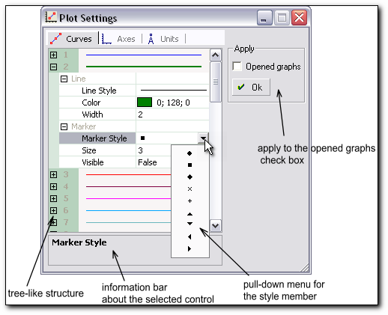
Figure 14. Plot Settings window.
- Curves
This tab menu defines the Curve style. It is very similar to the Curve Options panel.
Once the Plot Settings window is open, you can activate any accessible Plot Settings control by selecting one of the various components of the tree-like structure on the left side of the window. You then expand the tree by clicking on the plus signs (+) to expose additional Graph elements.
To choose the Curve style, WinCurve uses the group incremental list to automatically assign a visually distinct set of plot characteristics to each data set in the group. This feature works by incrementing the members of a style list for each plot element: Line Style, Line Color, Line Width, Marker Style and size. The incremental list can be customized.
Procedure to modify the increment list:
- Open the Plot Settings window and activate the Curves tab.
- Open tree-like structure of the desired Curve by clicking on the plus sign (+).
- Choose the Line Style and Marker Style from pull-down menu.
- Choose the Line Color from the Color pop-up window.
- Repeat operation 2 to 4 for all desired Curves.
- Check the ‘Apply to opened graphs’ check box if you want to apply the new incremental list to already opened Graph windows.
- Click OK button to save the new incremental list.
- Axes
This tab menu defines the Axis parameters. It is has the same controls as the Axes Options & Bg panel, except for the ‘Curve’ mode properties. The Min and Max values for the ‘Curve’ mode are dimmed. Upon loading the file, default Axis limits are taken from the extreme data points of the Curves belonging to the loaded file.
- Units
This tab defines the measurement Units. It has the same controls as the Units panel.
The new settings will automatically apply only to raw data files. For processed files, it is necessary to reopen the Plot Settings window and check the ‘Apply to opened graphs’ check box in order to have this particular plot schema. Otherwise, the Plot Settings which were used the last time for a processed file will be used again.
Contents

View Menu
From this menu you can select the toolbars, status bar and panels to be visible.
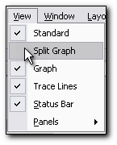
Figure 15. View Menu.
Contents

Window Menu
The Window Menu commands provide a way to manage the placement of the Graph windows in the Graph area.
- Cascade
This menu command sets the opened Graph windows in the available Graph area in cascade.
- Tile
This menu command sets the opened Graph windows into a tile arrangement.
- Arrange Icon
This menu places the minimized Graph windows at the bottom of the Graph area.
- List of the opened Graph windows
By checking a file from this list you make the Graph window corresponding to the checked file active.
- Windows…
Opens the Windows dialog window. It shows a list of the currently opened files and it has eight buttons to arrange the opened Graph windows in the Graph area. You can make group operations with the opened Graph windows from here by selecting several files. To do so, press the Ctrl or Shift key while making multiple file selections.
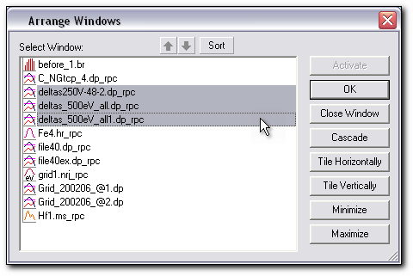
Figure 16.Windows dialog window.
- Activate. Makes the Graph window corresponding to a selected file active. This command is available when there is only one selected file.
- OK. Closes the dialog window.
- Save. Saves the selected files. If you press this button, WinCurve opens an alert box for every selected file, requesting you to save it.
- Close Window(s). Closes the selected files and corresponding Graph windows. This command opens an alert box for every selected file, requesting you to save it.
- Cascade. Arranges the selected group of files in cascade. A minimum of two files has to be selected.
- Tile Horizontally. Arranges the selected group of files side by side horizontally. A minimum of two files has to be selected. All the available Graph area is used.
- Tile Vertically. Arranges the selected group of files side by side vertically. A minimum of two files has to be selected. All the available Graph area is used.
- Minimize. Minimizes the selected files to the bottom of the Graph area.
Contents

Layout Menu
This menu provides an access to the different layouts.
You can dock panel groups to each other or to one of the docking panels. After you customize the panel groups, you can save the Workspace layout as a panel set. With panel sets, you can switch between different layouts to suit different types of work. Later, you can open the Workspace layout. You can manage your Workspace by saving a multiple panel set, removing a panel set that you no longer use or restoring the default layout.
The menu contains the ‘Restore to Default’ command, a textbox for the layout title, and five prepared layouts:
- Restore to Default
This menu command restores the default layout. You can not change this layout setting.
- Title
This is a text-box for the title of checked layout. You can give it any name. To register the given name press ‘Enter’.
- Layout 1-5
These layouts are changeable. To restore a chosen layout, simply click the layout name.

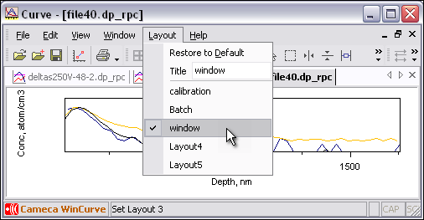
Figure 17. An example of the layout without any panel.
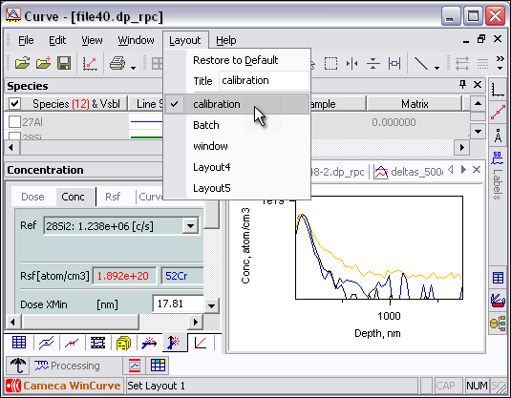
Figure 18. An example of the layout with panels.

In order to switch between two layouts, it is enough to check the desired layout name. This fact is demonstrated on the two figures above. The first one shows a prepared layout with only the Graph window occupying the WinCurve Workspace. On the second, we have a layout with the Graph window, Species panel, one group of docked panels and two groups of auto-hide panels.
Simply clicking the name for another prepared layout with predefined panel positions allows you to instantly obtain a complicated panel combination. WinCurve admits having up to five predefined layouts.
The layout with the checked name is automatically saved on your exiting the program. When the program is opened, the last used layout is restored.

Contents

Help Menu
- WinCurve Help
This menu command opens the WinCurve help.
- About WinCurve
This menu command opens the information window ‘About Curve Processing’. In this window, there is information about the version number and the release date.
- Trace Com
For developers' needs only.
Contents

ToolBars
WinCurve provides four toolbars with 25 toolbar buttons for frequently used commands. To facilitate using the toolbars, there is a tool-tip with the command name for each button. Tool-tips appear when you point to a toolbar button with the mouse. The button description is also shown in the Status Bar at the bottom of the Workspace.

Standard Toolbar
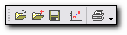
This toolbar consists mostly of the standard tools for the file operations.

 | Open (Ctr + O) | Opens Open data file window
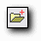 | Add (Ctr + A) | Opens Add File window
 | Save (Ctr + S) | Saves the file
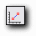 | Show Plot Settings | Opens Plot Settings window
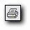 | Print (Ctr+P) | Opens Print Setup window

All of these buttons are doubled in the main Menu commands.
Contents

Split Graph Toolbar
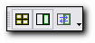
This toolbar contains buttons for a convenient distribution of data between several split Graphs. The split Graphs belong to the same Graph window.

 | Split into Intervals | Splits the mass spectrum data into different windows. The number of windows is defined by the number of measured intervals, plus a window for data transfer.
 | Split for Data Transfer | Splits Graph window in two .
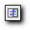 | Data Transfer | Transfers Curves into a second window.

Procedure for Data Transfer:
- Press the ‘Split for Data Transfer’ button. The Graph window splits up into two parts. The first window with the preexisting data acquires an orange outline; a second window with the default axes appears. These Axes correspond to the data type. For depth profile files, they are not calibrated.
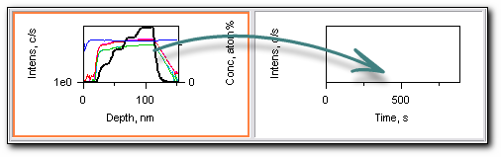
- Click mouse cursor anywhere inside the second window (window for data transfer). It becomes active and acquires a green outline. The ‘Data Transfer’ button is activated.
- Press the ‘Data Transfer’ button. The pull-down menu with a list of the available Curves for data transfer appears.
- Choose the desired Curve to be transferred. The chosen Curve appears in the second window.
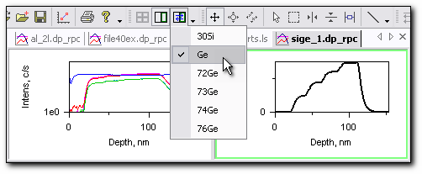
- If desired, choose another Curve to be transferred from the pull-down menu.

To return to the non split Graph window state press the ‘Split for Data Transfer’ button again.

Split into Intervals:
If you have interval data type, such as a mass spectrum, WinCurve allows you to present this data more conveniently. Press the ‘Split into Intervals’ button and the Curves distribute themselves between the new windows: every Curve is in its own window. In this way, you can see all the particularities of this data.
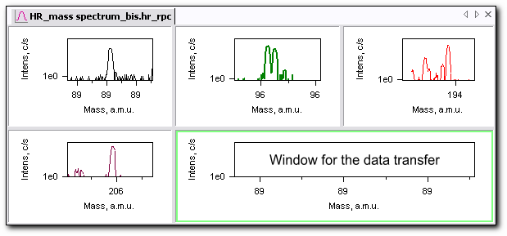
Figure 19. Mass spectrum split into intervals.

Procedure for Data Transfer for interval data type:
- Press the ‘Split into Intervals’ button. Several windows, each one with its own data series, appear. A final, empty window for data transfer also appears. The first window with the data acquires an orange outline. The ‘Split for Data Transfer’ button is activated.
- Press the ‘Split for Data Transfer’ button.
- Click mouse cursor anywhere inside the last empty window (window for data transfer). It becomes active and acquires a green outline. The ‘Data Transfer’ button is activated.
- Press the ‘Data Transfer’ button. A pull-down menu with a list of the available Curves for data transfer appears.
- Choose the desired Curve to be transferred. The chosen Curve appears in the last window.
- If desired, choose another Curve to be transferred from the pull-down menu.

To return to the non split Graph window state consecutively press the ‘Split for Data Transfer’ and then the ‘Split into Intervals’ buttons.

Contents

Graph Toolbar
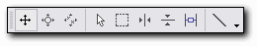
This toolbar includes the tools for convenient data view and drawing Lines in the Graph window.
 | Scroll Axes | Scrolls X or Y Axis in the Graph window.
Procedure to scroll Axis:
- Press the Scroll Axes button.
- Place the mouse cursor in the tick labels area of the desired axis. The hand-cursor appears:
- Press the left mouse button. A dashed outline appears. Drag Axis with the mouse cursor.
- Release the mouse cursor when Axis is in the desired position.

To simultaneously zoom Axis, click CTRL while dragging the cursor with the left mouse button pressed down.

 | Zoom Axes | Zooms in or zooms out of the X or Y Axis in the Graph window.

Procedure to apply a zoom to the Axis:
- Press the Zoom Axes button.
- Place the mouse cursor in the tick labels area of the desired axis. The two-way arrow appears:
- Press the left mouse button. A dashed outline appears. Do one of the following:
  - For an abscissa Axis: to zoom in, drag the cursor to the right; to zoom out, drag it to the left.
  - For an ordinate Axis: to zoom in, drag the cursor to the top; to zoom out, drag it to the bottom.
- Release the mouse button when the desired zoom is achieved.

To simultaneously scroll Axis, click CTRL while dragging the cursor with the left mouse button pressed down.

In order to undo a zoom, use the Auto Axes.

 | Auto Axes | Sets X and Y Axes to fit the Graph window or to a constant value. You can choose one of these modes from the pull-down menu.
The Auto Axes may be applied in three modes:
- Zoom to fit. In this mode the Axes are adjusted according to the extreme data points of the Curves.
- Zoom to constant. In this case the maximum Axis boundary values may be defined by the operator in the Axes Options & Bg Panel. The default boundary values are defined in the Plot Settings Window.
- Zoom to Interval. This procedure may only be applied for the interval data type: the mass spectrum, the high resolution spectrum or on the bar graph. There is a choice between several intervals where the data is located.

When this toolbar button is used, the Axes are auto-scaled in both X and Y directions.

You can make the Auto Axes procedure only in one direction (abscissa or ordinate).
Procedure to apply Auto Axes only in one particular direction:
- Place the mouse cursor in the X or Y Axis area of the Graph.
- Press the right mouse button. A pop-up menu appears.
- Choose ‘Zoom to fit’, ‘Zoom to constant’ or eventually ‘Zoom to interval’.

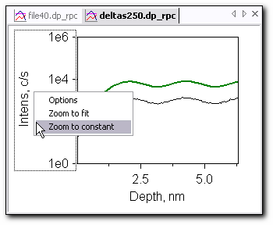
Figure 20. Auto Axes example for a depth profile.
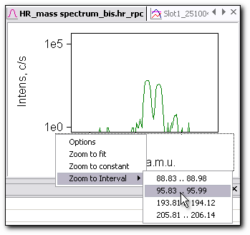
Figure 21. Auto Axes example for a mass spectrum.

 | Select | Selects, resizes and rotates the Lines. Moves Labels and Lines. This tool may be applied only if there are Labels or Lines in the Graph window.
Procedure to move Line:
- Press the ‘Select’ tool button.
- Place mouse over the desired Line.
- When the four-side arrow appears, press the left mouse button. Two square marks appear at the ends of the Line. They mark the Line that is selected.
- Move Line into desired position.
- Release the mouse button.

Procedure to resize and rotate Line:
- Press the ‘Select’ tool button.
- Place mouse over an end of the desired Line.
- When the two-side arrow appears, press the left mouse button. Two square marks appear at the ends of the Line. They mark the Line that is selected.
- Drag an end of the Line into desired position. The other end of the Line remains stuck.
- Release the mouse button.

Only one Line at a time can be selected.

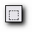 | Zoom Area | Zooms in the selected area in the Graph.
Procedure to apply a zoom to the Graph:
- Select a ‘Zoom Area’ tool.
- Set the mouse cursor in the Graph window on the point corresponding to the left upper corner of the area to be zoomed. A white rectangle sticks to the cursor:
- Press the left mouse button.
- Drag the mouse cursor. An outlined zoom selection is drawn.
- When the box frames the area to be zoomed, release the left mouse button. The boxed area fills the whole Graph window.

In order to undo a Zoom, use the Auto Axes.

 | Cursor X | Shows or hides cursor X. Reads the ordinate from an abscissa value. The updated values appear in the X and Y columns of the Species panel.
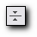 | Cursor Y | Shows or hides cursor Y. The Y coordinate appears in the Y column of the Species panel.
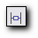 | Delta Cursor | Shows or hides interval cursor for X and Y Axes. You can choose X or Y delta cursor from the pull-down menu.

Procedure to set Delta Cursor:
- Select the ‘Delta Cursor’ tool. A pull-down menu appears.
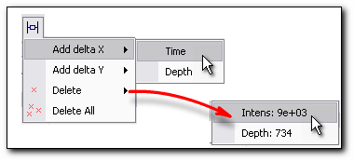
- Place mouse over ‘Add delta X’ or ‘Add delta Y’ menu item.
- If on the active Graph several X Axes (Time, Depth…) or several Y Axes (Intensity, Concentration…) exist, then the next level of the menu with the names of these Axes appear. Select the desired Axis by clicking the mouse. The blue delta cursor marks appear in the Graph window.
- Place the mouse over the delta cursor border in the Graph window. The hand-cursor appears:
- Press the left mouse button and drag the cursor to the desired position.
- Release the mouse button.
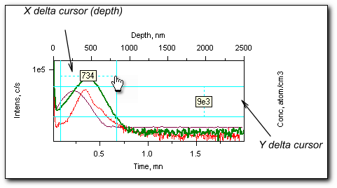
Figure 22. Delta cursors positions.

The value of the delta cursor is shown in the box between the cursor marks. The precision of this value is defined by the corresponding Axis precision.
You can delete delta cursors from their pull-down menu by selecting ‘Delete’ button and pressing the delta cursor name.

 | Draw Line | The Line drawing tool applies to add a straight line or arrow to the Graph.

Procedure to draw Line:
- Click on the ‘Draw Line’ tool.
- Click the left mouse button and drag it to the desired location in the Graph window.
- Release the mouse button and the line with arrows on both sides is displayed. It is selected with two squared marks at the ends of the line.
- Set the desired properties for the line style using the ‘Trace Line’ toolbar. Rotate and resize line with the ‘Select’ tool.

Any changes made to the size of the Graph window will produce a proportional scaling of the drawn lines.

Contents

Trace Lines Toolbar
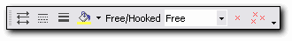
This toolbar panel becomes available when a Line object in the Graph window is selected.
Procedure to select Line:
- Click on the ‘Select’ tool.
- Place the mouse anywhere on the Line to be selected. The four-side arrow appears.
- Press the left mouse button. Two square marks appear at the ends of the Line. They mark the Line that is selected. The ‘Trace Lines Buttons’ are activated. Now it is possible to set the desired properties for the line style.

 | Line Style | Defines line style: simple line, one-way arrow or two-way arrow.
 | Dash Style | Defines dash style. This button is available only if the Line Width is set to 1; otherwise the button is dimmed.
 | Line Width | Defines line width.
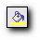 | Line Color | Defines line color.
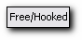 | Free/Hooked | Defines if a selected line is free or hooked to any Curve. You can choose from the pull-down menu.
 | Delete Line | Deletes selected line.
 | Delete All Lines | Deletes all lines.

Contents

Snap Acquisition
The Snap Acquisition progressively shows the measurement results in the active Graph window during the analysis time. This function permits to compare the real time data with the previous results.
To open the Snap Acquisition panel:
  - In the main menu, select File, Snap Acquisition…
or
  - Click the Snap Acquisition tab on the stacked panel if it is present in the Workspace at the moment. By default, the Snap Acquisition panel is presented in the panel group on the left side of the Workspace.
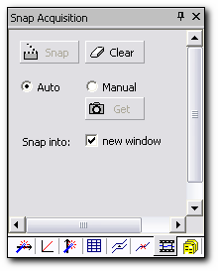
Figure 23. Snap Acquisition Panel.

The Snap Acquisition panel contains:
- ‘Snap’ button. Press it to begin the Snap Acquisition procedure.
- ‘Clear’ button. Press it to stop the Snap procedure and erase the data.
- ‘Get’ button. Press it to make a unique snapshot of the current analysis.
- ‘Auto’/’Manual’ radio-buttons. Use them to toggle between the auto and manual modes.
- ‘Snap into new window’ checkbox. Check it to put the Snap results into new Graph window.
- Message area. Indicates the file name into which the snap data are collected.

The ‘Snap’ and ‘Get’ buttons are dimmed while the Analysis program stands idle. When the Analysis starts, the ‘Snap’ and ‘Get’ buttons become available and it is possible to begin the Snap Acquisition procedure. There are two modes for updating the snap data:
- Auto mode. The new data points are added at the end of every cycle of the current acquisition.
- Manual mode. The new data points are added on request by pressing the ‘Get’ button.
It is possible to toggle between two modes while running analysis with no limitations.

If you launch the Snap Acquisition procedure when there are no currently opened files, then a new file with the name snap_acquisition.dp_rpc will be opened. Otherwise, you have a choice between the snap into new Graph window or to the active Graph window. A new file with the name snap_acquisition.dp will be added to the opened file which corresponds to the active Graph window if you do not check the check box ‘Snap into new window’. This active file must have the same analysis type as the snap being performed. If you restart the Snap procedure for the same opened file, then a new file with the indexed name snap_acquisition”Number”.dp will be added to the currently opened file. Once data points have been started collected into Graph window, they become independent of the current acquisition and have the same status as any other Curves and therefore can be processed in WinCurve.
To start the Snap Acquisition procedure:
- Open the Snap Acquisition panel.
- Select the ‘Curve update’ mode. The default mode is ‘Auto’.
- Press the ‘Snap’ button for ‘Auto’ mode. The snapped data is loaded into the current Graph window.
To stop the Snap Acquisition procedure:
- From the Snap Acquisition panel, toggle to ‘Manual’ mode, selecting the corresponding radio button.
The 'Clear' button stops the Snap procedure and erases the snapped data loaded in the active Graph window.

Contents

Species Panel
Species is a stand-alone panel. It provides all significant information about loaded Curves.
To open the Species panel:
  - By default, the Species panel is presented at the top of the Workspace.
or
  - In the main menu, select View, Panels, Species.
or
  - Press the keyboard shortcut Ctr+Shift+S.
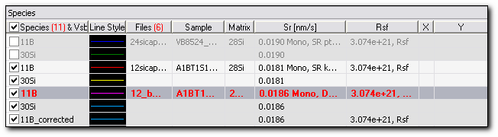
Figure 24. Species panel.
The Curves in the WinCurve program may have a visible or invisible status (in Graph window). If there is data loaded from different files, then in the Species list it appears in alternating shades of gray. There is no user editable space in the Species panel. The current Curve is the selected Curve with the selected status; its name and characteristics appear in red (the color can be customized in the Application Options Panel). It is possible to choose the current Curve from the Graph window: to do so, double-click on the desired Curve.
The current Curve appears in white in the Graph window except on a white background; there it is traced in black.

You can delete a Curve from the Species panel.
Procedure to delete a Curve:
- Place the mouse cursor over the name of the Curve you want to delete.
- Press the right mouse button. A ‘Delete Curve’s name’ pop-up box appears. There is a choice between the deletion of only one chosen Curve or the deletion of all Curves belonging to the same file as a chosen Curve:
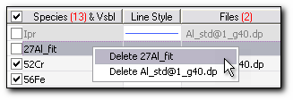
- Select the desired option. An alert window appears.
- Press “Yes” to confirm deletion or “No” otherwise.

The alert widow to confirm Curve deletion appears only if the property Confirm deletion in the Application Options panel is turned on. Otherwise, the Curve is deleted without any prompt.

You can also delete a Curve from the Delete panel and the Processing panel.

The Species Panel consists of several columns used to control and define the Curves corresponding to each Species.
  - Species and their visibility. This column provides the Species names and tells which Species are visible in the Graph window. The total number of Species is shown in red on the column heading. Every Species has:
- A check box which must be marked with the symbol to load the Curve to the Graph window. Click on the square ( ) in order to change the Curve's visibility status.
- An identification label of the Curve.
At the top of the column there is a check box which is used to select Species of a certain type. A right mouse click on it opens the Select Species pull-down menu from which it is possible to choose a Specie of a certain type; whereupon all opened Species of that type are selected. A left mouse click on this check box selects or deselects all loaded Species.
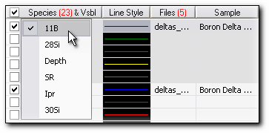
Figure 25. A Select Species pull-down menu.
  - Line style. The loaded Species have a particular color sequence. This sequence is defined in the Plot Settings window, but any color can be changed by the user.
  - Files. This column provides the file names of the overlaid files. The number of the overlaid files is shown in red on the column heading.
  - Sample. This is the name of the measured sample.
  - Matrix. This is the matrix name. The matrix may be changed only for depth profile files in the Depth calibration panel.
  - Sputter Rate (nm/s) is used only for depth profile files. It shows a measured Sputter Rate in nm/s with its associated depth calibration method. The applied calibration method is the same for the file and so it is shown only once for the whole file.
  - RSF is used only for depth profile and line scan file types. It shows a RSF value with its associated concentration calibration method.
  - X/Y. These columns show the value of an abscissa - determined by a cursor swept along a Curve - and its ordinate. The cursor motion can be under mouse or keyboard control.

If the cursor position is validated for an abscissa lower than the first data point of the current Curve or for an abscissa higher than the last data point of the current Curve, the cursor abscissa is entered, but the ordinate does not exist.

Contents

Graph Window Control

Axes Options and Background Panel
This control panel defines the Axes properties. The Axes provide the way that your data is plotted.
To open the Axes Options and Background control panel:
  - Double click the Axis area of the Graph. (Axis area has thin black dotted outline.)
or
  - Press the right mouse button on the Axis area of the Graph. The pop-up menu appears. Select ‘Options’ from this menu.
or
  - In the main menu, select View, Panels, Axes.
or
  - Press the Axes Options tab on the stacked panel if it is present in the Workspace at the moment. By default, the Axes Options panel is presented in the panel group on the right side of the Workspace.
or
  - Press the keyboard shortcut Ctr+Shift+X.

The Axes Options & Bg control panel defines the properties of the currently selected Axis. The currently selected Axis is identified in the pull-down menu on top of this panel. To edit another Axis, select it from the pull-down menu. When you edit Axis properties, they apply immediately to the active Graph window.
Global presets for the Axes are defined in the Plot Settings Window.
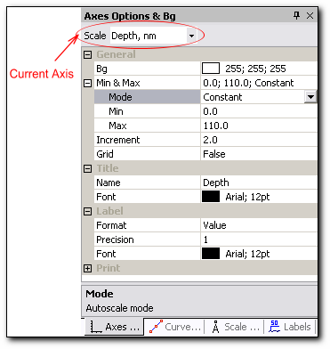
Figure 26. Axes Options and Background panel.

The Axes control panel defines the following properties:
- General: Background. Select background color for the Graph window from the pop-up color window.
- Min & Max properties define the Min and Max of the selected Axis and also some parameters for the Auto Axes function.
  - Mode. Select ‘Constant’ or ‘Curve’ mode from pull-down menu.
In ‘Constant’ mode, the Min and Max are the limits for the ‘Zoom to constant’ Auto Axes function.
In ‘Curve’ mode, the Min and Max are the current Axis limits. You can enter them directly by keyboard or by applying ‘Scroll Axes’ or ‘Zoom Axes’ procedures.
  - Min. Type desired min limit value.
  - Max. Type desired max limit value.
- Increment. Select increment for Axis tick labels.

You can select an increment only for a linear scale, for the logarithmic scale WinCurve defines it itself.

- Lin/Log. Select which scale to use, linear or logarithmic, from pull-down menu.
- Grid. Select ‘True’ or ‘False’ from pull-down menu.
- Title.
  - Name. Type the title of the Axis.
  - Font. Select the font for the Axis title from the pop-up font window.
- Label. Defines format parameters for the Axis labels.
  - Format. Select ‘Value’ or ‘Exponent’ from pull-down menu.
  - Precision. Select the number of decimal signs to show for Axis labels by pressing on the spin button. The maximum number of decimal signs is 6.
  - Font. Select font for the Axis labels from the pop-up font window.
- Print. Defines which format parameters will apply to the printed Graph.
  - Background. Select background color for the Graph from the pop-up color window.
  - Title Font. Select font for the Axis title from the pop-up font window.
  - Labels Font. Select font for the Axis labels from the pop-up font window.
Contents

Curve Options Panel
This control panel defines how the Curve is drawn in the Graph window. The global presets for the Curve style are defined in the Plot Settings window.
To open the Curve Options control panel:
  - Place mouse cursor over desired Curve.
Click the right mouse button. Pop-up ‘Curve options’ appears.
Press it.
or
  - In the main menu select View, Panels, Curves.
or
  - Click on the Curve Options tab on the stacked panel if it is present in the Workspace at the moment. By default, the Curve Options panel is presented in the panel group on the right side of the Workspace.
or
  - Press the keyboard shortcut Ctr+Shift+V.
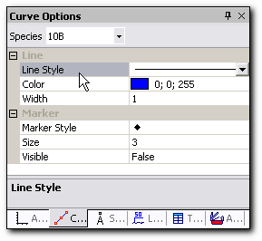
Figure 27. Curve Options panel.
The Curve Options control panel defines the following properties:
- Line properties of the Curve:
  - Line Style. Select the dash style of the Curve from pull-down menu. There are five embedded dash styles. These styles can be only applied if the Line Width is set to 1; otherwise the solid line style is applied.
  - Color. Select the Curve color from the pop-up color window.
  - Width. Select the Curve width by pressing on the spin button. You can choose from 1 to 5.
- Marker properties:
  - Marker Style. Select marker style from the pull-down menu. There is a total of 9 marker styles.
  - Marker Size. Select marker size by pressing on the spin button. You can choose from 1 to 7.
  - Visible. Select ‘True’ or ‘False’ from the pull-down menu, thus defining if there are markers or not.
Contents

Units Panel
This control panel presents all the measurement units available in WinCurve. It defines the units for the active Graph window; the global presets for the units are set in the Plot Settings window.
To open the Units control panel:
  - In the main menu, select View, Panels, Units.
or
  - Click on the Units tab on the stacked panel if it is present in the Workspace at the moment. By default, the Units panel is presented in the panel group on the right side of the Workspace.
or
  - Press the keyboard shortcut Ctr+Shift+N.

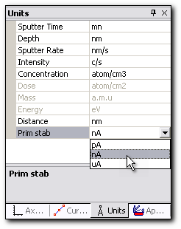
Figure 28. Units panel.
To change the units for a selected measurement, click on the corresponding pull-down menu and select the desired units. Units with only one possible magnitude are dimmed.

In WinCurve, ten Axis dimensions are available: six for the Y Axis (Depth, Intensity, Concentration, Sputter Rate, Dose and Primary ion current) and four for the X Axis (Sputter time, Mass, Energy and Distance). If a Curve has a dimension not mentioned above, it appears as without dimension (Adim) in the Graph window.
Contents

Labels Panel
From the Labels panel you may add, save, delete and load existed text objects to your Graph window. This control panel defines how the text objects are presented in the Graph window.
To open the Labels control panel:
  - Double click on any Label.
or
  - Place mouse cursor over any Label.
Click the right mouse button. Pop-up ‘Label options’ appears.
Press it.
or
  - In the main menu, select View, Panels, Labels.
or
  - Press the Labels tab on the stacked panel if it is present in the Workspace at the moment. By default, the Labels panel is presented in the panel group on the right side of the Workspace.
or
  - Press the keyboard shortcut Ctr+Shift+B.

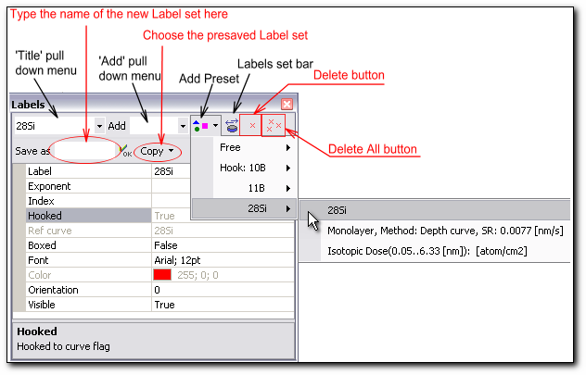
Figure 29. Labels panel.

Procedure to add a new Label to the Graph window:
- Activate the Labels panel.
- Choose ‘Free’ or ‘Hooked’ from the ‘Add’ pull-down menu on top of the Labels control panel.
- A label with the name ‘New’ appears in the ‘Label’ box and in the ‘Title’ pull-down menu. You may then change it from the ‘Label’ box.
Procedure to add a preformatted label to the Graph window:
- Click on the ‘Add Preset’ pull-down menu.
- Choose the label from the ‘Free’ or ‘Hooked’ preset list. You have a choice of:
Free labels | File name  Sample name  Matrix name  Some applied Processing names and their characteristics
Hooked labels | Curve name (Curve must be present in the Graph window)  Some applied Processing names and their characteristics

In WinCurve, there is a possibility of saving the Label set for further use. You can reuse a previously made Label set.
Procedure to save the Label set:
- Press the ‘Label set bar’ button; two new boxes appear on the Labels panel: the ‘Save as’ box and the ‘Copy’ pull-down menu box.
- Type the name of the label set to be saved in the ‘Save as’ box. You can save up to five label sets.
Procedure to reuse the Label set:
- Press the ‘Label set bar’ button; two new boxes appear on the Labels panel: the ‘Save as’ box and the ‘Copy’ pull-down menu box.
- Open the ‘Copy’ pull-down menu.
- Select desired Label set. All free labels from the preformatted set will be used. The hooked labels from the preformatted set will only be used if a Curve with the same title as the one they are hooked to is present in the Graph window.
To delete the current Label: use the ‘Delete’ button.
To delete all Labels: use the ‘Delete All’ button.
The Labels control panel defines the following properties:
- Label. Change the label title or choose it from the ‘Title’ pull-down menu on top of this panel.
- Exponent. Type superscript for the label title if necessary.
- Index. Type subscript for the label title if necessary.
- Hooked. It is an unavailable property. It tells if the Label is free or hooked to any Curve.
- Ref curve. Tells to which Curve the label is hooked. This property is dimmed.
- Boxed. Select ‘True’ or ‘False’ from pull-down menu.
- Font. Select font for the label from the pop-up font window.
- Color. Shows the label font color. The label color corresponds to a particular Curve color if the label is hooked to this Curve. Label color is red for the free labels.
- Orientation. Select the label orientation from pull-down menu.
- Visible. Select ‘True’ or ‘False’ from the pull-down menu, thus defining if the label is visible or not.

You can move the Labels if the ‘Select’ toolbar button is activated.

Contents

Application Options Panel
This control panel allows customizing the data presentation in the Graph window and in the Species panel.
To open the Application Options control panel:
  - In the main menu, select View, Panels, App Options.
or
  - Click the Application Options tab on the stacked panel if it is present in the Workspace at the moment. By default, the Application Options panel is presented in the panel group on the right side of the Workspace.
or
  - Press the keyboard shortcut Ctr+Shift+P.

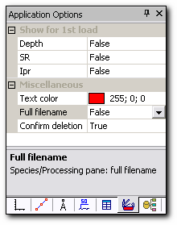

Figure 30. Application Options panel.

The Application Options control panel defines the following properties:
- Show for 1st load: these properties define the data presentation in the Graph window for the raw data files. This property may be applied only to the three Curve types listed below:
  - Depth. Select ‘True’ or ‘False’ from the pull-down menu.
  - SR (Sputter Rate). Select ‘True’ or ‘False’ from the pull-down menu.
  - Ipr (Primary Current). Select ‘True’ or ‘False’ from the pull-down menu.
- Miscellaneous properties allow customizing the file presentation in the Species panel:
  - Text Color. Select the color of the current Curve for the Species panel from the pop-up color window. The default color is red.
  - Full Filename. Select ‘True’ or ‘False’ from the pull-down menu, thus defining if the full filename is used in the Species panel or not.
  - Confirm deletion. Select ‘True’ or ‘False’ from the pull-down menu. This setting defines the confirmation for Specie deletion in the Species and Processing panels.

Contents

Presentation and Data Management

Table Panel
This panel helps improve the data presentation in the printed document. You can make any table here and this table will be printed together with the Graph.
The Table is presented with the Graph only in the printed document.

To open the Table panel:
  - In the main menu, select View, Panels, Table.
or
  - Click the Table tab on the stacked panel if it is present in the Workspace at the moment. By default, the Table panel is presented in the panel group on the right side of the Workspace.
or
  - Press the keyboard shortcut Ctr+Shift+T.

The Table panel consists of three parts:
- Table control area with the following properties, which will apply to the printed table:
- Title Font. Select font for the column title from the pop-up font window.
- Data Font. Select font for the data from the pop-up font window.
- Grid. Select ‘True’ or ‘False’ from the pull-down menu, thus defining if the grid will be seen in the printed Table or not.
- Visible. Select ‘True’ or ‘False’ from the pull-down menu, thus defining if the table will be in the printed document.
- The Table toolbar:
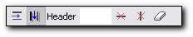
The Table toolbar consists of six buttons:

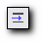 | Insert Row | Inserts row below the selected row
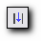 | Insert Column | Inserts column to the right of the selected column
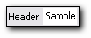 | Header | The field for entering the column header.
To validate the header name you have to press ‘Enter’ key.

 | Delete Row | Deletes selected row
 | Delete Column | Deletes selected column
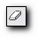 | Clean Table | Deletes all values from the table except the headers

- The Table itself.
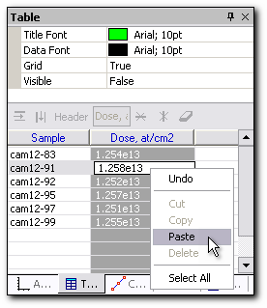
Figure 31. Table panel.
To enter data directly into the worksheet, type the value into the cell. If you make an error when typing data or want to change a value in a cell, left-click the cell once to highlight it and type the correct value. WinCurve automatically overwrites the value in the cell. You can also paste the values into the table from the clipboard.
To select a row of the table, mouse click on this row; to select a column, you have to click on the column header.
When you print the Graph from WinCurve, depending on the paper orientation, the table will occupy different positions on the printed sheet. For the portrait orientation, the table will be printed at the bottom of the document and for the landscape orientation; it will be printed on the left side of the document.
Contents

Comments Panel
This panel is used for data presentation in the printed document. The Comments will be printed together with the Graph.
To open the Comments panel:
  - In the main menu, select View, Panels, Comments.
or
  - Click the Comments tab on the stacked panel if it is present in the Workspace at the moment. By default, the Comments panel is presented in the panel group at the bottom of the Workspace.
or
  - Press the keyboard shortcut Ctr+Shift+M.

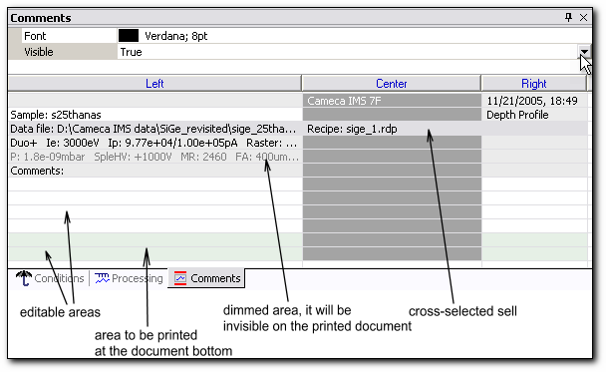
Figure 32. Comments panel.

The Comments panel consists of two parts:
- Comments control area with the following format properties, which will apply to the printed Comments:
- Font. Select font from the pop-up font window.
- Visible. Select ‘True’ or ‘False’ from the pull-down menu, thus defining if this part of the Comments will be shown on the printed document or not. The Comments area which is chosen as 'invisible' is dimmed.

By default, the formatting is applied to the selected row. If you wish to apply formatting to one cell only, this cell has to be cross-selected.

To make the cross selection, first, select the row to which the desired cell belongs, then select its column by clicking on the column header. Formatting will apply to this cross selection. To deselect the column click on the column header again.

- The comments themselves. The areas in white and green can be edited, the grey areas are unavailable for changing. The comments contain three columns and several preformatted horizontal parts:
- Cameca instrument type in the center with the measurement date and time on the right.
- The sample name on the left with the analysis type on the right.
- The full name of the data file on the left with the recipe name in the center.
- Analytical measurement conditions on the left.
- Comments. This is an editable area for your own comments. To enter your comments into the worksheet, left-click the cell once to highlight it, then type the comments into the cell.
The Comments will be printed at the top of the document except for personal comments, written in the green area. These will be printed at the bottom of the document.
The document printed directly from WinCurve is composed by:
- Comments
- Active Graph
- Table
- User personal Comments
The Graph in the document is printed to scale or fit to page if too large. If there is a table present in the document to be printed, the Graph is scaled down to fit both on the same page.
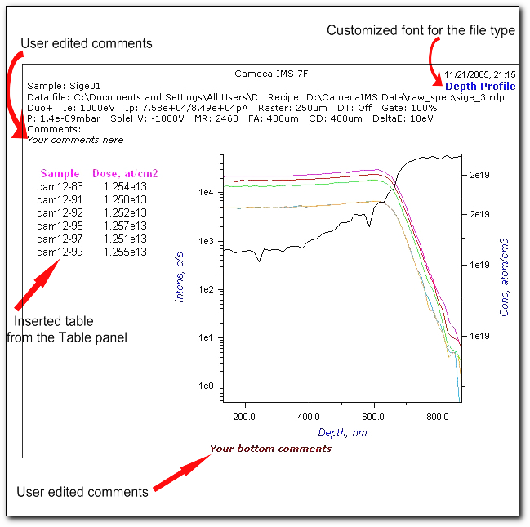
Figure 33. Example of the printed document with the inserted Table and Comments.

The Comments are always present in a document printed from the Print menu. If you do not want them to be visible, set the visibility status to ‘False’ for each comment.
Contents

Analytical Conditions Panel
This panel presents the Analytical Conditions set for the file containing the current Curve.
To open the Analytical Conditions panel:
  - In the main menu, select View, Panels, Phy Cond.
or
  - Click the Conditions tab on the stacked panel if it is present in the Workspace at the moment. By default, the Conditions panel is presented in the panel group at the bottom of the Workspace.
or
  - Press the keyboard shortcut Ctr+Shift+H.

The Analytical Conditions panel is realized as a browser and so it has some browser properties. On right-clicking the panel area, a pop-up menu appears. You can call the standard commands like ‘Select’, ‘Copy’, ‘Print’ from there.
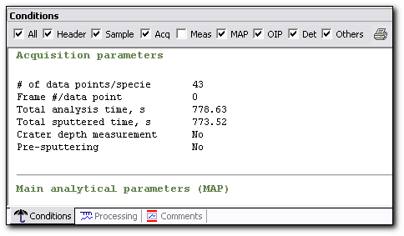
Figure 34. Analytical Conditions panel.

The Analytical Conditions are divided into eight main groups:
- Analysis header
- Sample position
- Acquisition parameters
- Measurement conditions
- Main analytical parameters (MAP)
- Optional instrument parameters (OIP)
- Ion detector parameters
- Others
You may print a chosen set of Analytical Conditions from WinCurve.
 To see the Analytical Conditions for a different sample presented in the file, make any Curve from the desired sample the current one.

Contents

Data Summary Panel
In this panel it is possible to make, save and open an existing Data Summary report. A new report is generated from processed and raw data files. It includes the analytical conditions used for data acquisition as well as the results obtained in the quantification procedure. Quantification parameters can also be shown in the Data Summary report table if needed. A Data Summary report is generated without opening the corresponding files in the Graph window. It is presented as a table with a chosen number of columns. This table can be saved in a special format with the extension dt_sm.
To open the Data summary panel:
  - In the main menu, select View, Panels, Data Summary.
or
  - Click the Data Summary tab on the stacked panel if it is present in the Workspace at the moment. By default, the Data Summary panel is present in the panel group at the bottom of the Workspace.
or
  - Press the keyboard shortcut Ctr+Shift+Y.

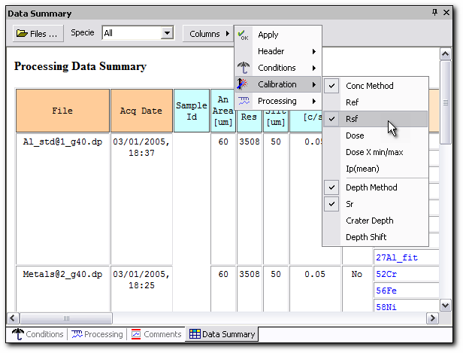
Figure 35. Data Summary panel.
The Data Summary panel is a tool to generate the report for processed or raw data files, which load separately from the Graph window. The Columns menu of this panel shares its appearance with the menu Edit-Report-Data Summary Columns and with the Columns menu of the Batch panel Data Summary report.

The Data Summary panel consists of two parts:
- The panel toolbar with buttons and pull-down menu:
- Files. This button opens the Select Data File window. This is a standard file dialog box. You can add one or many processed and raw data files of any type to the report.
- Specie. This is a filter for the Species which are present in the loaded files. From the pull-down menu, choose the desired Specie to be inserted into the report.
- Columns. Click this button to choose analytical conditions, calibration results and processing parameters which will be inserted into the Data Summary report. They are presented in the report as columns with alternating colors.
- Export. This button is used to open an existing report, save it, or place it on the clipboard for further use in different office applications or in the print function.
- The generated Processing Data Summary report.
Procedure to make a Data Summary report:
- Activate the Data Summary panel.
- Click the File button and chose desired files from the Select Data File window.
- Choose All or one desired Specie from the Specie pull-down menu.
- Click the Columns button and select a header, analytical conditions, calibration results and processing parameters to be presented in the report.
- Click the Columns button and then Apply to reformat the report appearance in the Data Summary panel.
- Click Export and then Save As… to save the Data Summary report in a special format with the extension dt_sm for further use.

The file filename.dt_sm contains not only the columns selected at the moment of the creation of the report, but also all other data from the chosen processed and raw data files. Therefore, upon subsequent loading of the filename.dt_sm file, the table presentation can be changed.

The Data Summary report table can be copied to the clipboard for future presentation of it in any office application program.

Contents

Word Report Generation
The menu command Edit-Report-Word Template… is used to make an automated report for an active Graph window in Word format. WinCurve is supplied with three prepared Word templates for the generation of the report. They can be edited and saved for further use.
The WinCurve template is a Word file with a doc extension, which can contain any text, image, graph information or bookmark. Bookmarks define the point where an object of a certain type will be inserted. For graphs, they also determine the size of the area in which the graph will be contained. On the template, this area is filled with the tree picture. To view the Word report bookmarks the option ‘View Bookmarks’ in the Tools/Options Microsoft Word menu has to be checked. After the execution of an embedded template the bookmarks are removed automatically and replaced by graph or table objects.
Usually, a report consists of a heading, several pictures, instrument conditions and measured and processed data in the form of graphs or tables. The Report form is a formatted file containing some essential parameters of the analysis and graph snapshots (raw/processed, axis Lin/Log etc), including an optical image of the surface. The preface/header/footer of the report form is customizable. Sometimes it is convenient to generate a report only with the measurement conditions and sometimes only with a Data Summary table. Therefore, for users’ convenience, the corresponding templates are supplied.
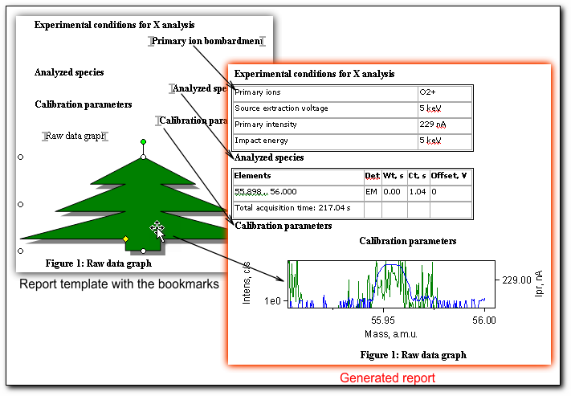
Figure 36. Examples of a saved template and Word report.
Eight pairs of bookmarks are prepared for insertion into a template and provided with WinCurve. Each pair of bookmarks indicates the start and end position for an object of a certain type. Object type is shown in the table below.
Embedded bookmarks for report generation:

 | Bookmark name | Object type
1. | Graph1 Start  Graph1 End | Processed Graph
2. | Graph2 Start  Graph2 End | Raw data Graph
3. | Legend1 Start  Legend1 End | Processed Graph Legend  This legend corresponds to the legend used in the Species panel.
  Species |  | X units | Y units
  11B |  | nm | c/s
  28Si |  | nm | c/s
  Depth |  | s | nm
  SR |  | nm | nm/s
  SR_corr |  | nm | nm/s
  Depth_corr |  | s | nm
4. | Primary Ion Start  Primary Ion End | Experimental Condition Table
  Primary ions | O2+
  Source extraction voltage | 5 keV
  Primary intensity | 574 nA
  Impact energy | 5 keV
  Incidence angle
  Beam blanking | No
  Raster size | 200 m
5. | Spectrometer Start  Spectrometer End | Spectrometer Parameters Table
  Vacuum in analysis chamber | 9.250e-09 mbar
  Polarity | +
  Extraction voltage | 5000 V
  Max area
  Dynamic Transfer Optical System | Off
  Electronic gate | 81 %
  Contrast aperture | 300 m
  Field aperture | 1200 m
  Analyzed area size | 150 m
  Mass resolution (m/Δm) at 10%) | 400
  Energy band pass | 45 eV
  EM post-acceleration voltage
  Oxygen flooding | No
  Liquid Nitrogen Trap, LN₂
  Normal incidence Electron Gun | No
6. | Species Start  Species End | Measurement Condition Table
  Elements | Det | Wt, s | Ct, s | Offset, V
  11B | EM | 1.04 | 2.48 | 0
  28Si | FC | 0.88 | 1.04 | 0
  Total acquisition time: 480.24 s
  Reference signal: No
  Interferences:
7. | Calibration Start  Calibration End | Calibration Parameters Table
  Sputter Rate (SR known) | 14.8780 nm/s
  RSF 28Si 14N / Ref Ref sig, 28Si: 4.837e+06 c/s | 5.222e+20 atom/cm3
8. | Data Summary Start  Data Summary End | Data Summary Table
  File | Acq Date | Sample Id | Holder Id | Specie | Mass Field
  Sige01.dp | 11/21/2005, 20:55 | Sige01 | 4_holes | 30Si | 440107
   |  |  |  | 70Ge | 674820
   |  |  |  | 72Ge | 684482
   |  |  |  | 73Ge | 689270
   |  |  |  | 74Ge | 694009
   |  |  |  | 76Ge | 703437

If the report is supposed to contain a Data Summary table, then the columns for it have to be selected from the Edit-Report-Data Summary Columns menu.
Procedure to make a Word report:
- Choose the Edit/Report/Data Summary Columns menu item.
- Check the desired header, Analytical conditions, Calibration results and processing parameters to be presented in the report.
- Choose the Edit/Report/Word Template… menu item. The ‘Open Word Template’ file dialog window opens.
- Choose the desired report template. The template file has a doc extension. The report is generated.
- Make notes, remarks or corrections in the report if needed.
- Give the report a unique name and save it.

The menu command Edit-Report-Data Summary Columns shares its appearance with the Batch Processing Data Summary report and with the Data Summary panel Columns menu.

Contents

ASCII Data Panel
This panel allows exporting data in the ASCII text format.
To open the ASCII Data panel:
  - In the main menu, select View, Panels, ASCII Data.
or
  - Click the ASCII Data tab on the stacked panel if it is present in the Workspace at the moment. By default, the ASCII Data panel is presented in the panel group on the left side of the Workspace.
or
  - Press the keyboard shortcut Ctr+Shift+A.

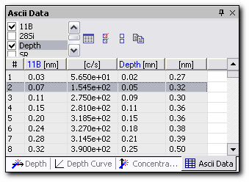
Figure 37. ASCII Data panel.

The ASCII Data panel consists of two parts:
- The panel toolbar with the buttons and scroll list:
- The scroll list. Select the Species you want to import in ASCII format.
- Refresh. Click this button to show selected data in the table below.
- Select All. Click this button to select all Species.
- Deselect All. Click this button to deselect all Species
- Copy to Clipboard. Click this button to copy the selected Species to clipboard. You can then import them into another file.
- The ASCII data table itself.
Contents

Copy Curves Panel
This panel is used for adding specific Curves to the active Graph window. You can add the chosen Curves from already opened files; these files have to be of the same type as the one to which you add the Curves.
To open the Copy Curves panel:
  - In the main menu, select View, Panels, Copy.
or
  - Click the Copy Curves tab on the stacked panel if it is present in the Workspace at the moment. By default, the Copy Curves panel is presented in the panel group on the left side of the Workspace.
or
  - Press the keyboard shortcut Ctr+Shift+O.
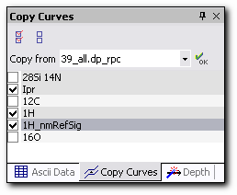
Figure 38. Copy Curves panel.

The Copy Curves panel consists of two parts:
- The panel toolbar with the buttons and the pull-down menu:
- Select All. Click this button to select all Curves from chosen file.
- Deselect All. Click this button to deselect all Curves from chosen file.
- Copy from. Select the file from which you want to copy the Curves. Only the opened files of the same type are shown.
- OK. Click this button to execute copy.
- The Species list with the check boxes. You have to choose the Curves to be copied here. If there is data loaded from different files, then in the Species list it appears in alternating shades of gray.
You can also add Curves to the opened file from the main menu, but from there all the Curves of the chosen file are added.

Contents

Delete Curves Panel
This panel is used for deleting the Curves from the Graph window. You can delete the chosen set of Curves.
To open the Delete Curves panel:
  - In the main menu, select View, Panels, Delete.
or
  - Click the Delete Curves tab on the stacked panel if it is present in the Workspace at the moment. By default, the Delete Curves panel is presented in the panel group on the left side of the Workspace.
or
  - Press the keyboard shortcut Ctr+Shift+E.
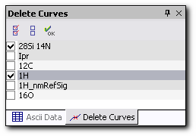
Figure 39. Delete Curves panel.
The Delete Curves panel consists of two parts:
- The panel toolbar with the buttons:
- Select All. Click this button to select all Species.
- Deselect All. Click this button to deselect all Species.
- OK. Click this button to delete the selected Curves.
- The Species list with the check boxes. You have to choose the Curves to be deleted here. If there is data loaded from different files, then in the Species list it appears in alternating shades of gray.
Procedure to delete the Curves:
- Activate the Delete panel.
- Select the Species to be deleted.
- Press ‘OK’ button to delete selected Curves.

The selected Curves are all deleted together and without any prompt.

There is also the possibility of deleting the Curves from the Species panel and from the Processing panel, but one by one.

Contents

Compatibility with the CAMECA UNIX Based Curve Program
The WinCurve program supports files processed by the previous CAMECA UNIX based Curve program. These files have the same extension as WinCurve files: analysis type_rpc. Despite their name the format of the data inside the files is different.
The fact that the current file is generated by UNIX is reflected in the Analytical Conditions panel. In the information about the file type, it is written: “UnixCurve proc file”. When WinCurve handles such a file, it simultaneously looks for the corresponding raw data file. Thus, it is preferable, if possible, to locate these two files together or in neighboring directories. The search time is limited and if WinCurve does not find the raw data file, the corresponding message is added to the Analytical Condition panel and some of the analytical experimental parameters will be unavailable. If WinCurve locates the raw data file then it fills in all the parameters on the Analytical Conditions panel.
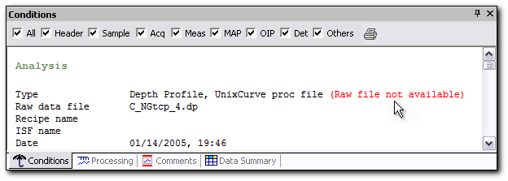
Figure 40. Information provided for the UNIX Curve processed files.
The UnixCurve processed files are read along with all the parameters of the processing that has been performed on those files, with all applied formatting such as: labels, colors, line styles and annotations. Though there is information about performed processing, the processing made by UnixCurve can not be undone. The new processing can be applied to the old Curve and could eventually be undone.
The UnixCurve processed file opened by WinCurve can not be saved with the same name. It has to be renamed after its first opening in WinCurve.

Contents

Depth Calibration
This function executes the time scale to depth scale conversion.
In general, the depth scale is computed from the Sputter Rate, which depends on the time. The depth of the Nth data point of a Curve is computed by the following relationship:
, for N>1
or
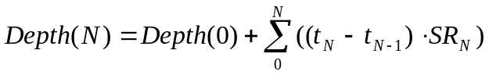
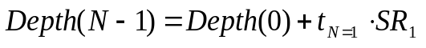
where:
t_{N} holds the acquisition time of the Nth data point of the current Curve.
Depth(0) is the depth shift, introduced by operator.
All Curves belonging to a given file are depth calibrated together.

When both depth calibration and concentration calibration are executed on the same Curve, the depth calibration should preferably be carried out first.
For the Depth calibration there are the following options:
  - Monolayer depth calibration for a sample analyzed with a constant Sputter Rate.
  - Multilayer depth calibration for a sample analyzed with a variable Sputter Rate.
  - Computed Depth Curve.
  - In-situ, laser interferometer.

A depth calibration can not be undone only if the Curve is already calibrated in concentration using known Dose calibration method.

To open the Depth calibration panel:
  - In the main menu, select View, Panels, Depth Calib.
or
  - Click the Depth tab on the stacked panel if it is present in the Workspace at the moment. By default, the Depth calibration panel is presented in the panel group on the left side of the Workspace.
or
  - Press the keyboard shortcut Ctr+Shift+D.
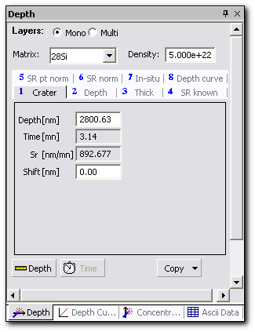
Figure 41. Depth panel.
Depth calibration tools on the Depth panel:
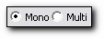 | Mono/Multi radio buttons | Toggle between monolayer and multilayer Depth calibration mode.
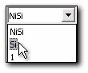 | Matrix pull-down menu | Shows the matrix name written in the file (matrix ID) for the selected Curve. The Matrix name can be chosen from the list in the pull-down menu.
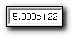 | Density field | Shows a unique Density (in at/cm³) of the Matrix. The Density field can be edited by the operator.
 | Cursor on button | Shows cursor X. Two modes are possible: single cursor mode and double cursor mode.
 | Cursor off button | Hides cursor X.
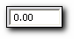 | Sift field | Shows the depth shift. This field can be edited by the operator. This operation is equivalent to introducing an offset in the Depth Axis.
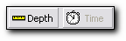 | Depth / Time buttons | Toggle between depth and time scale.
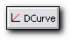 | Depth Curve button | Visualizes the Depth Curve in the Graph window.

Note that validations in the text entering fields in WinCurve must be made by pressing the Enter key on the keyboard - not the mouse button.

Copy Function for Depth Calibration
The Copy button opens the pull-down menu with the list of recently performed calibrations. The 15 last calibrations are shown. Every item in this list opens another information level with the date, Matrix name, depth shift and applied Depth calibration method and its parameters.
Each time a depth calibration is carried out, the file name and the associated calibration parameters are saved in the Calibration list of Copy function. The 15 last applied depth calibrations are stored.
An example of the Calibration list is shown in figure below.
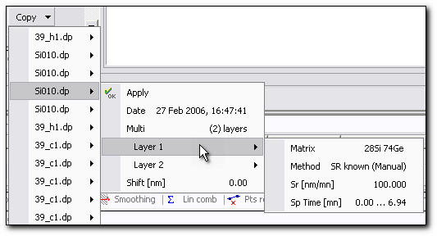
Figure 42. Calibration list of Copy function for Depth calibration.

The depth calibration last applied is added to the top of the list.
The Copy function saves all applied calibration parameters accurately, and it is possible to exactly reproduce a calibration previously applied to another file by pressing the ‘Apply’ command in the pull-down Copy menu.
Contents

Depth Curve
Depth Curve gives the correspondence between Time and Depth scale, so, any known measurement time can be converted into depth during the Depth calibration procedure.
The Depth Curve can be obtained as a result of:
  - The laser interferometer measurement (this Curve is called Depth).
  - The Depth Calibration procedure (the Curve has a name Depth_calib).
After applying the Depth calibration the Depth Curve button becomes available and after clicking on it, the Depth_calib Curve appears in the Species panel and in the Graph window. You can view its points in the Depth Curve panel. If you now restore the non calibrated status of the Curves, the Depth_calib Curve remains present.
The Depth_calib Curve may be deleted from the Species panel or from the Delete Curves panel.

The Depth Curve which obtained in-situ measurements is only one Curve which can not be depth calibrated.
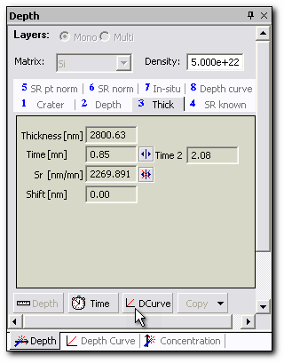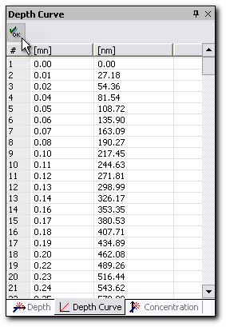
Figure 43. Depth calibration and Depth Curve panels.
Contents
The Sputter Rate may be obtained by different modes.

Crater Mode
In the Crater mode the Sputter Rate is calculated from the Crater depth and the Total sputtering time by using the following relationship:
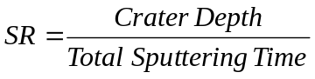
Depth calibration Procedure in the Crater mode:
- Activate Depth panel and then select the Crater tab.
- Select the Mono radio button.
- Enter the matrix name from pull-down Matrix menu. If a matrix name is entered in the acquisition program, it will appear automatically.
- Enter the crater depth value in the Depth editing field by using the keyboard. Press the Enter key. This value is automatically set to correspond to the total sputtering time. The SR field is updated.
- Click Depth button to execute Depth calibration. The Graph window is updated. The present Sputter Rate value, the sputtering time and the crater depth values are saved in the Calibration list of Copy function.
- Click Time button, if required, to restore the non calibrated Curve.
You can toggle the Graph scale by pressing the Depth and Time buttons .

Contents

Depth Mode
The Depth mode is used when the depth is known for one particular point (an interface, a peak maximum position). In this case the Sputter Rate is calculated from the known depth value and from the analysis time which is necessary to reach this point:
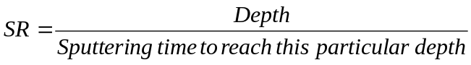
Depth calibration Procedure in the Depth mode:
- Activate Depth panel and then select the Depth tab.
- Select the Mono radio button.
- Enter the matrix name from pull-down Matrix menu. If a matrix name is entered in the acquisition program, it will appear automatically.
- Select the Cursor on mode by pressing the button. The green X cursor appears.
- Enter the sputtering time corresponding to the known depth value by using either the keyboard or dragging the X cursor in the Graph window. The default value is the abscissa of the last point of the file data. The Sputter Rate field is updated.
- Enter the depth value in the Depth field by using the keyboard. Press the Enter key. The Sputter Rate field is updated.
- Click Depth button to execute Depth calibration. The Graph window is updated. The present Sputter Rate value and the sputtering time value are saved in the Calibration list of Copy function.
- Click Time button, if required, to restore the non calibrated Curve.
Contents

Thickness Mode
The Thickness mode is used if the thickness between two points is known. In this case the Sputter Rate is calculated from the known thickness value between two points:
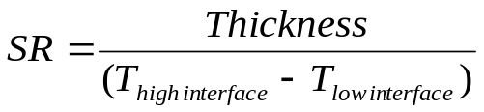
In general, there is no difference between the Depth and Thickness modes. The Depth mode is a particular case of the Thickness mode. Depth calibration can be made if we suppose the position of the first interface equal to zero.

Depth calibration Procedure in the Thickness mode:
- Activate Depth panel and then select the Thick tab.
- Select the Mono radio button.
- Enter the matrix name from the pull-down Matrix menu. If a matrix name is entered in the acquisition program, it will appear automatically.
- Select the Cursor on mode by pressing the . button. Two green X cursors appear.
- Enter the sputtering time corresponding to the low and high interfaces of the known layer by using either the keyboard or dragging the X cursors in the Graph window. The default values are the abscissa of the first and of the last point of the file data.
- Enter the thickness value in the Thickness editing field by using the keyboard. Press the Enter key. The Sputter Rate field is updated.
- Click Depth button to execute Depth calibration. The Graph window is updated. The present Sputter Rate value and the sputtering time interval are saved in the Calibration list of Copy function.
- Click Time button, if required, to restore the non calibrated Curve.
Contents

SR Known Mode
The SR known mode is used if the Sputter Rate is known and constant. In this case the Sputter Rate value is entered directly by operator or in the case of the most recent instruments Cameca IMS WF, a Sputter Rate Curve can be obtained in-situ. For new Cameca IMS WF instruments, an option for depth calibration in-situ is available, since they are equipped with an online crater measurement (OLC) system.
In SR known mode, the Sputter Rate value is constant throughout the measurement. It may be entered manually into the SR editing field. The Cursor on/off function is also available. This function can work in two modes: a single cursor mode, which returns the Sputter Rate value at a given point (SR_at_point), or a double cursor mode which returns the mean Sputter Rate value between two points (SR_mean). For the last two cases the Sputter Rate value can not be edited by the keyboard.
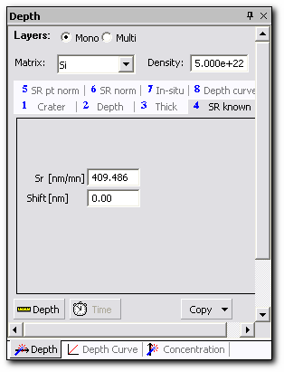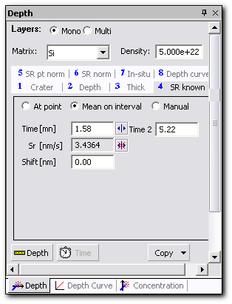
Figure 44. Depth calibration panel: Sputter Rate known mode (on the left, the panel for manual Sputter Rate entry is shown; on the right, the panel for the file with the measured in-situ SR Curve is shown).

Depth calibration Procedure in the SR known mode:
- Activate Depth panel and then select the SR known tab.
- Select the Mono radio button.
- Enter the matrix name from the pull-down Matrix menu. If a matrix name is entered in the acquisition program, it will appear automatically.
- If there is no measured SR Curve in the file or if you select the ‘Manual’ radio button, then type the Sputter Rate value in the SR field by using the keyboard. Press the Enter key. The Sputter Rate field is updated.
- If there is a measured SR Curve in the file, select the ‘At point’ or ‘Mean on interval’ radio button.
- Select the Cursor on mode by pressing the button. One or two green X cursors appear, depending on the choice made.
- Enter the sputtering time corresponding to the low and high X cursors by using either the keyboard or dragging the X cursors in the Graph window. The default values are the abscissa of the first and of the last point of the file data. The SR field is updated. The SR mean value is taken on the selected interval from the measured SR Curve saved in the current file.
- Click Depth button to execute Depth calibration. The Graph window is updated. The present Sputter Rate value and the sputtering time value or interval are saved in the Calibration list of Copy function.
- Click Time button, if required, to restore the non calibrated Curve.
Contents

SR Point Normalization Mode
The SR point normalization mode is used to correct the Sputter Rate from the Primary Ion current value measured during the analysis time. This allows for correcting the Sputter Rate in a series of measurements depending on the variations of the Primary Ion current from one measurement to another. The Sputter Rate is considered as a constant value in each analysis; however, its value can change from one analysis to another.
The Cameca WF and newest IMS 7f instruments are equipped with a continuous primary current monitoring system and a Primary Ion current Curve can be obtained.

For the Sputter Rate point normalization:
- It is supposed that the Sputter Rate is proportional to the Primary Ion current.
- It is necessary to enter the reference values: a certain value of the Primary Ion current Ip ref which corresponds to a certain value of the Sputter Rate SR ref.
In this case the Sputter Rate is calculated according to the formula:
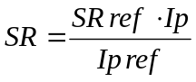
where:
SR ref and Ip ref are the corresponding values of the reference file; they are entered by the operator and they give the correspondence between the Sputter Rate and the Primary Ion current. Default value is the analysis average Primary Ion current.
Ip is the Primary Ion current value during the analysis time. By default, the mean value of the Primary Ion current is proposed:
- If the Ip Curve is present, the mean value of the Primary Ion current is the mean value of the all points of the Ip Curve.
- If the Ip Curve is not present, the mean value of the Primary Ion current is the mean value of the Primary Ion current measured before and after analysis. This value can be edited by the operator if, for example, there is one mistaken point in the Curve.
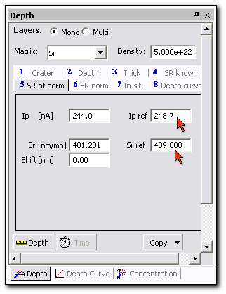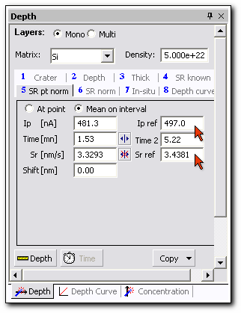
Figure 45. Depth calibration panel: SR point normalization mode (on the left, the panel for the file measured without the Ip Curve is shown; on the right, the panel for the file measured with the Ip Curve is shown).

Depth calibration Procedure in the SR point normalization mode:
- Activate Depth panel and then select the SR pt norm tab.
- Select the Mono radio button.
- Enter the matrix name from the pull-down Matrix menu. If a matrix name is entered in the acquisition program, it will appear automatically.
- Select the ‘At point’ or ‘Mean on interval’ radio button if any one of them is present in the panel at the moment.
- Select the Cursor on mode by pressing the button. One or two green X cursors appear, depending on the choice made.
- Enter the sputtering time corresponding to the low and high X cursors by using either the keyboard or dragging the X cursors in the Graph window. The default values are the abscissa of the first and of the last point of the measured Ip Curve. The Ip field is updated. The Ip mean value is taken in the selected interval from the measured Ip Curve saved in the current file.
If there is no measured Ip Curve in the file, then the default Ip mean value which is taken from the Measurement Conditions is shown in the Ip field.
- Enter SR ref and Ip ref by keyboard in the corresponding fields. Each time, press the Enter key. The values are taken from the reference file. The SR field is updated.
- Click Depth button to execute Depth calibration. The Graph window is updated. The present Sputter Rate value and the sputtering time interval or value are saved in the Calibration list of Copy function.
- Click Time button, if required, to restore the non calibrated Curve.
Contents

SR Normalization Mode
The SR Normalization mode is used to correct the Sputter Rate from the possible variations of the Primary Ion current during the analysis time. The Sputter Rate is not constant. For this normalization:
- It is supposed that the Sputter Rate is proportional to the Primary Ion current.
- It is necessary to enter the reference values: a certain value of the Primary Ion current Ip ref which corresponds to a certain value of the SR ref.
There are two distinctive cases:
- The measurements of the Ip are made only at the beginning and at the end of analysis (IMS 7f/4fE7 and previous instruments).
- Ip Curve is measured in-situ (IMS WF).

In the first case, if the Ip Curve is not present, the Sputter Rate is calculated from:
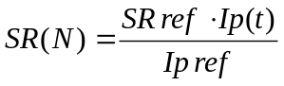

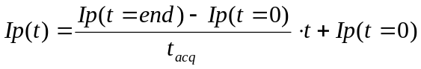
where:
SR ref and Ip ref are the reference values; they are entered by the operator and they give the correspondence between the Sputter Rate and the Primary Ion current. The default value is the analysis' average Ip.
Ip(t=0) is the Primary Ion current value measured at the beginning of analysis.
Ip(t=end) is the Primary Ion current value measured at the end of analysis.

In the second case, if the Ip Curve is present and chosen by the operator, the Sputter Rate is calculated from:
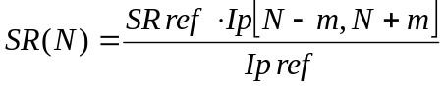
where:
SR ref and Ip ref are the reference values; they are entered by the operator and they give the correspondence between the Sputter Rate and the Primary Ion current.
Ip[N-m,N+m] is the Primary Ion current for the N cycle; this value is the mean Primary Ion current value in the interval [N-m,N+m]. The total number of points in consideration (2m+1) is always an odd number, and it is editable by the operator. For the first acquisition cycle N-m points are not present: the mean value for the first cycle is taken over the interval [N,N+2m]. The mean value for the second cycle is taken over the interval [N,N+2m+1] and for the following cycles it is N=(m+1). The same applies to the cycles at the end of the acquisition.
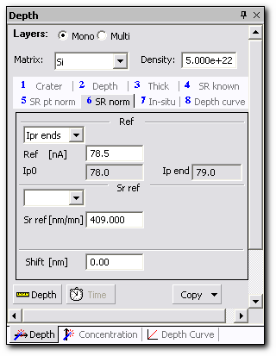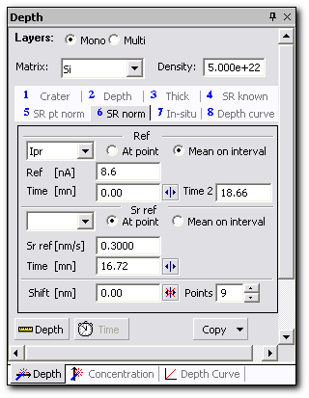
Figure 46. Depth calibration panel: SR normalization mode (on the left, the panel for the file measured without the Ip Curve is shown; on the right, the panel for the file measured with the Ip Curve is shown).

Depth calibration Procedure in the SR normalization mode without measured Ip Curve:
- Activate Depth panel and then select the SR norm tab on Depth panel.
- Select the Mono radio button.
- Enter the matrix name from the pull-down Matrix menu. If a matrix name is entered in the acquisition program, it will appear automatically.
- Select the Ipr end value from the pull-down menu at the Ref part of the panel. You have a choice of all measured Species plus the Ipr end value.
- Enter the Ref value by keyboard.
- Enter the SR ref value by keyboard at the SR ref part of the panel.
- Click Depth button to execute Depth calibration. The Graph window is updated. The present Sputter Rate value, the Ipr ref value and the sputtering time value or interval are saved in the Calibration list of Copy function.
- Click Time button, if required, to restore the non calibrated Curve.
Depth calibration Procedure in the SR normalization mode with the measured in-situ Ipr Curve:
- Activate Depth panel and then select the SR norm tab on Depth panel.
- Select the Mono radio button.
- Enter the matrix name from the pull-down Matrix menu. If a matrix name is entered in the acquisition program, it will appear automatically.
- Select the reference Curve from the pull-down menu at the Ref part of the panel. You have a choice of all Curves present in the file: all measured Species, plus the measured in-situ Depth, SR and Ipr Curves. The corresponding value and units appear in the Ref field.
- Select the ‘At point’ or the ‘Mean on interval’ radio button at the Ref part of the panel.
- Select the Cursor on mode by pressing the button at the Ref part of the panel. One or two green X cursors appear, depending on the choice made.
- Enter the sputtering time corresponding to the low and high X cursors by using either the keyboard or dragging the X cursors in the Graph window. The default values are the abscissa of the first and of the last point of the chosen reference Curve. The Ref field is updated. The mean value taken in the selected interval from the chosen reference Curve Ref is saved in the Calibration list of Copy function.
- Select the SR reference Curve from the pull-down menu at the SR Ref part of the panel. There, you have a choice from the measured SR Curve and processed Curves with Sputter Rate units. The corresponding value appears in the SR Ref field.
- Select the ‘At point’ or ‘Mean on interval’ radio button at the SR Ref part of the panel
- Select the Cursor on mode by pressing the button at the SR Ref part of the panel. One or two green X cursors appear, depending on the choice made.
- Enter the sputtering time corresponding to the low and high X cursors by using either the keyboard or dragging the X cursors in the Graph window. The default values are the abscissa of the first and of the last point of the chosen SR reference Curve. The SR ref field is updated. The SR ref mean value is taken in the selected interval from the chosen SR reference Curve.
- Enter number of points by pressing the ‘Points’ spin button. This is the number that defines the interval width for Ip normalization.
- Click Depth button to execute Depth calibration. The Graph window is updated. The present Sputter Rate value, the Ipr ref value and the sputtering time value or interval are saved in the Calibration list of Copy function.
- Click Time button, if required, to restore the non calibrated Curve.
Contents

In-situ Mode with the Sputter Rate Correction
This calibration mode is available if the depth measurement is performed in-situ with the laser interferometer system (for the instruments CAMECA IMS WF). There is a depth measurement associated to every data point. The Depth Curve shows this correspondence. The time to depth conversion is performed point to point using the Depth Curve.
This system returns a measured depth value Depth, which is
Depth = Depth_corr + error,
where Depth_corr is supposed as being the real depth value.
The error term is mostly related to perturbations of the laser beam wave fronts by the crater edges, to imperfections in the separation of the beam’s polarized components, as well as to defaults coming from the measurement HP card. The summing up of these errors results in a periodical error, which makes the measured Depth Curve oscillate.
The correction is based on the relationships between real and measured values for both Depth and Sputter Rate:
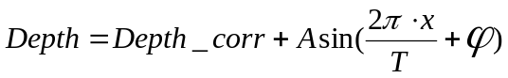 (1)
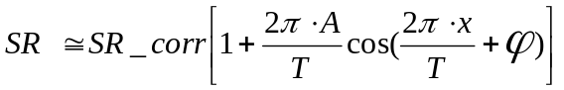 (2)
where:
x- abscissa (depth, nm),
A- amplitude,
- phase,
T- period.
The goal is to determine the values of  and, and eventually the value of the spatial period. It is preferable to find these values by using the Sputter Rate Curve.
Once, and the spatial period are defined, we can calculate the real sputter rate SR_corr by inverting the second relationship (2). Then the Depth Curve may be corrected; the real Curve Depth_corr is computed using the first expression (1).
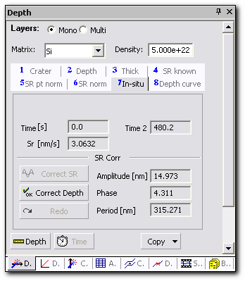
Figure 47. Depth calibration panel: In-situ mode.

Depth calibration Procedure for In-situ mode with the Sputter Rate oscillation correction:
- Activate Depth panel and then select the In-situ tab on the Depth panel.
- Select the Mono radio button.
- Enter the matrix name from the pull-down Matrix menu. If a matrix name is entered in the acquisition program, it will appear automatically.
- Click the Correct SR button. The Corrected Depth and Corrected Sputter Rate Curves appear in the Graph window. The Correct Depth button is undimmed. The Corrected Depth Curve looks like a straight line. The obtained values for, and the spatial period appear in the Amplitude[nm], Phase and Period[nm] fields respectively. These values are read only.
- If the operator is satisfied with the SR correction, it may be applied to the Depth Curve by clicking on the Correct Depth button. The Depth Curve is replaced by the Corrected Depth Curve and all further calculations are made with the aid of this corrected Curve. The Corrected Sputter Rate Curve is eliminated. The obtained correlation parameters , and the spatial period are saved in the History.
- Click the Undo button if the Corrected Depth Curve does not have desired properties.
- Click the Depth button to execute the Depth calibration. The Graph window is updated. The present Sputter Rate value, the sputtering time and sputtered depth intervals are saved in the Calibration list of Copy function.
- Click the Time button, if required, to restore the non calibrated Curve.
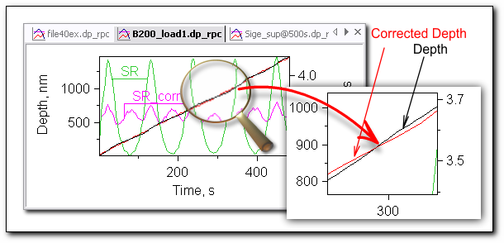
Figure 48. Sputter Rate oscillation correction.
Contents

Depth Curve Mode
This calibration mode is available from the moment when Depth calibration is performed with the aid of the measured Depth Curve. This Curve is made during the Depth calibration or it is measured in-situ.
Depth calibration Procedure in the Depth curve mode:
- Activate Depth panel and then select the Depth curve tab on Depth panel.
- Select the Mono radio button.
- Enter the matrix name from the pull-down Matrix menu. If a matrix name is entered in the acquisition program, it will appear automatically.
- Select the Depth_calib Curve from pull-down menu.
- Click Depth button to execute Depth calibration. The Graph window is updated. The present Sputter Rate value, the sputtering time and sputtered depth intervals are saved in the Calibration list of Copy function.
- Click Time button, if required, to restore the non calibrated Curve.
Contents

Multilayer Depth Calibration
The multilayer mode is used for Depth calibration if:
  - The matrix is the same while the Sputter Rate is changed during the acquisition time.
  - The sample has a multilayer structure made of different matrixes.
General rules for the multilayer mode:
- Several layers of the same matrix can be defined.
- Two consecutive layers made of the same matrix can be declared if sputtered with a different rate.
- The layer limits can be set arbitrarily.
- A gap with no parameter definition cannot exist between two layers.
- All layers are depth calibrated together at the same time.

Depth calibration tools on the Depth panel specific for the multilayer mode:
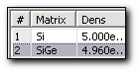 | Layer list | Provides a list of the defined layers. They are listed in increasing depth order, with the Matrix name. The layer name selected in the item list is the current entered layer.
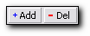 | Add/Del Layer buttons | Adds or deletes a layer in the Layer list. The layer can be added only at the end of the list. The low interface depth of the added layer is always equal to the high interface depth of the last entered layer.
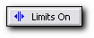 | X Limits On button | Shows cursor X limits
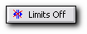 | X Limits Off button | Hides cursor X limits

The Crater mode and the Thickness mode are not available for the multilayer calibration.

The layers must be defined consecutively with the following rules:
- For the layer with N>1, the low interface is the same as the high interface of the layer with N-1, and the depth of the low interface of the layer N is the depth of the high interface of the layer with N-1:
Sput time(low) [layer N] = Sput time(hight)[layer N-1]
Depth(low)[layer N] = Depth(high)[layer N-1]
- For the first layer (N=1), the sputtering time and the depth of the low interface have the default values:
Sput time(low)[layer 1] = 0 (default)
Depth(low)[layer 1] = 0 (default)
Depth calibration made for one layer in the multilayer structure is the same processing which is applied to the monolayer structure.

The Depth mode
This mode is used when the depth values of the low and of the high layer interface are known. The operator defines two interfaces and the depth values correspondent to every interface. For the layer with N>1, the high interface is defined by the low interface of the layer with N-1. The layer is calibrated with the constant Sputter Rate defined from:
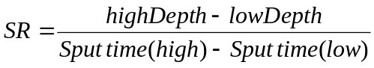
The SR known mode
This mode is used when the Sputter Rate value for the layer is constant and known. The operator defines two interfaces and then enters the Sputter Rate value. For the layer with N>1, the low interface is defined by the high interface of the layer with N-1.
The SR point normalization mode
The Sputter Rate value for the layer is corrected by the Ion Primary current mean value (Ip) on the corresponding time interval. The operator defines a reference Sputter Rate SR ref corresponding to a certain Ion Primary current value Ip ref, and so changes the Ip value.
The SR normalization mode
The Sputter Rate value for the layer is corrected by the Ion Primary current variations (Ip) on the corresponding time interval. These variations are defined by the Ip Curve if it exists, or else by the linear variation between the Ip values registered before and after the measurement. The operator defines the reference Sputter Rate SR ref corresponding to a certain Ion Primary current value Ip ref, and so changes the Ip value.
The Depth curve and In-situ modes
The Depth curve mode and the In-situ mode are available but they can be applied to the whole multilayer structure and not only to one chosen layer.
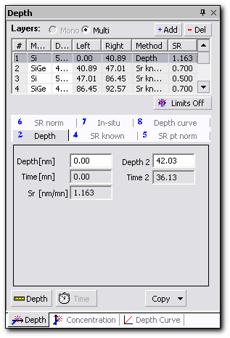
Figure 49. Depth calibration panel: multilayer case.
Depth calibration Procedure for multilayer sample:
- Activate Depth panel and then select the Depth curve tab on the Depth panel.
- Select the Multi radio button. The Layer list appears.
The Layer list consists of the following columns:
  - Layer number
  - Matrix name
  - Density
  - Left interface (low)
  - Right interface (high)
  - Calibration method
  - Sputter Rate
- Add the required number of layers by pressing the Add button. The interface limits appear in the Graph window. The number of interfaces is equal the number of layers minus one.
- Enter the matrix names from the pull-down Matrix menu. If a matrix name is entered in the acquisition program, it will appear automatically.
- Enter the sputtering times corresponding to the interfaces by dragging the interface limits in the Graph window.
- Enter the matrix name from the pull-down Matrix menu. If a matrix name is entered in the acquisition program, it will appear automatically.
- Click Depth button to execute Depth calibration. The Graph window is updated. All depth calibration parameters for all layers are saved in the Calibration list of Copy function.
- Click Time button, if required, to restore the non calibrated Curve.

Apply first the SR known mode for mono layer, thus the same calibration parameters will be set automatically for the added multilayer structure.

Contents

Concentration Calibration
This function executes the conversion of the secondary ion intensity of the current Curve in a concentration Curve following the relationship:
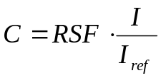
where:
RSF is the Relative Sensitivity Factor,
I is the secondary intensity,
I_{ref} is the secondary intensity of a reference signal.
Two methods can be used to compute the RSF value required to carry out the concentration calibration of the current Curve:
  - Dose method: the RSF is computed from the dose of the Species of interest and the integrated number of detected ions to record the Curve, with the relationship:
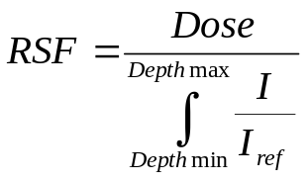

  - Concentration method: the RSF is computed from the intensity of a given data point N corresponding to a known concentration, with the relationship:
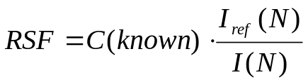
Any Curve belonging to a given file can be calibrated in concentration independently (keeping the other Curves not calibrated).

To open the Concentration Calibration panel:
  - In the main menu, select View, Panels, Conc Calib.
or
  - Click the Concentration tab on the stacked panel if it is present in the Workspace at the moment. By default, the Concentration calibration panel is presented in the panel group on the left side of the Workspace.
or
  - Press the keyboard shortcut Ctr+Shift+C.

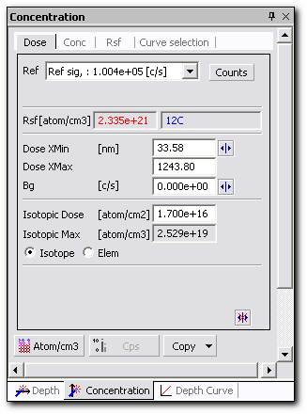
Figure 50. Concentration calibration panel.
Concentration calibration tools on the Concentration panel:
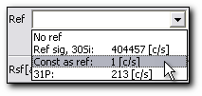 | Reference Signal pull-down menu | Opens a list of the possible reference signals.
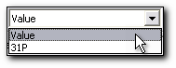 | ‘Const as ref’ pull-down menu | Opens the choice list in the ‘Const as ref’ reference signal mode.
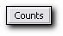 | Counts button | Allows editing the RSF value.
 | Cursor on button | Shows cursor. Two modes are possible: single cursor mode and double cursor mode.
 | Cursor off button | Hides cursor.
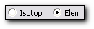 | Isotope/Element radio buttons | Toggle between Isotope and Element mode.
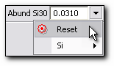 | Abundance pull-down menu | Shows natural isotope abundance of element and allows changing it.
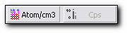 | Atom/cm³ / Cps buttons | Toggle between Atom/cm3 and Cps scale.

Reference Signal
The reference signal can be a Curve or a constant value. There are four possibilities in using the Reference signal:
- None - no reference signal is used.
In this case, the concentration is proportional to the measured signal. RSF has a meaning of useful yield, containing the information about ionization efficiency and the transmission factor. The operator introduces the RSF value manually or it is a result of the Copy function.
- Constant reference - reference signal is a constant value: I_{ref}.
In case of constant reference signal, its value is introduced by operator or it is calculated as an average value over an interval of the Curve, selected for reference signal calculation. The constant reference can be a result of the Copy function.
- Reference point – the reference signal has a value, I_{ref}, measured at the end of the profile.
The reference point is a secondary intensity measured either during the acquisition or at the end of the acquisition for a Species defined by the operator. This value is saved in the raw data file as a reference point. When a reference point exists in a file, it is automatically selected as a reference signal for the concentration calibration.
- Reference Curve - reference signal is one of the Curves of the present file.
The reference Curve signal must belong to the same file as the Curve to be calibrated and must not be calibrated in concentration. The normalization is carried out point by point. As a consequence of the sequential data acquisition, the abscissas of the point for the reference signal and for the Species of interest are not equal. In order to compensate this X scale data shift, the reference signal value is interpolated to the same abscissa as for the Species to be normalized. This interpolation is based on a cubic spline function fitting. Concentration in the point N is a product of the point-to-point normalization of the measured signal I_{element} to the I_{matrix} signal, multiplied to the RSF value in the current point. Operator introduces the RSF value manually or it is a result of the Copy function.
Contents

Copy Function for Concentration Calibration
The Copy button in the Concentration calibration panel opens the pull-down menu with a list of recently performed concentration calibrations. The performed concentration calibrations are sorted by Species name. The latest operation moves the corresponding element to the top of the list. For every element, a second level menu exists. It shows the file name, as well as the date and time at which the calibration was performed. The latest operation is added to the top. A third level menu contains the applied calibration parameters and the ‘Apply’ button.
Each time a concentration calibration is carried out, the file name and all associated calibration parameters are saved in the Calibration list of Copy function.
Even if you perform the de-calibration procedure, all parameters of the performed calibration remain written in the Calibration list of Copy function.

An example of a Calibration list is shown on figure below.
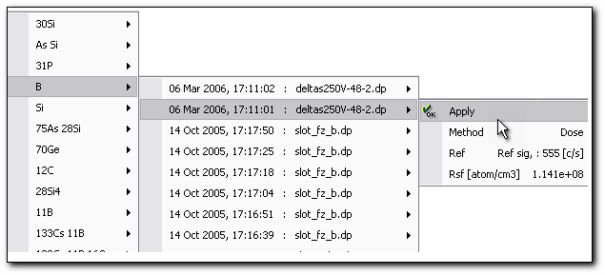
Figure 51. Copy function for Concentration calibration.

The functionality of the Copy function in the case of the Concentration calibration method is determined as follows:
  - It copies the Concentration value obtained in any calibration action previously completed, with its selection of the isotopic abundance value and isotopic or elemental calibration method.
  - The ‘Constant As Reference’ value has to be calculated from the actual data file if it is calibrated the same way as the calibration process to be copied. If ‘Constant as Reference’ value has been introduced by operator, this value has to be copied unchanged instead.
  - The cursor positions used for the calibration process are copied along with the Concentration calibration value from the previously calibrated file - cursor positions used for calculation of ‘Constant as Reference’ value with its selection of the Curve, and Dose calculation Xmin and Xmax coordinates and corresponding background cursor value used for Dose calculation.
  - In case of multi-layer calibration method Copy function becoming dependent on the Depth scale calibration, all layer boundaries have to be determined before Copy function can be accomplished. The Copy function uses the same calibration method for every determined layer as it has been used in the previously completed calibration. All conditions mentioned above are valid for multilayer calibration, which consider one layer in the file to be calibrated as one independent monolayer calibration procedure applied to a corresponding layer in the previously calibrated file.
Contents

RSF Method
This function determines the correlation between the intensity of the measured secondary ion signal and its concentration in the present sample. A linear dependence is supposed, where the Relative Sensitivity Factor is a coefficient of the proportionality between measured signal intensity and its concentration.
Two cases are to be distinguished:
  - Elemental RSF: calculation of RSF using isotopic abundance of the element to be processed. The concentration scale is corrected to take into account that only one isotope was measured. The concentration scale is relative to the Species (all isotopes are assumed to be present in the sample with their natural abundance).
  - Isotopic RSF: this calculation does not take into account the isotopic abundance correction of element of interest. In this case, the value of isotope abundance coefficient is set to 1. Isotopic abundance of the matrix element is not corrected for backward compatibility with the previous version of Curve Processing software.

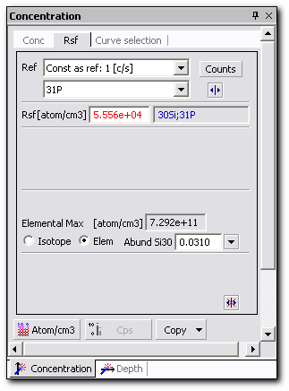
Figure 52. Concentration calibration panel: RSF method.
Pressing the Isotope/Elemental radio buttons gives access to RSF modification, according to the isotope abundance of the selected chemical element. The Isotope radio-button is used to select the isotopic concentration mode. The Elem radio-button is used to select the elemental concentration mode.
Selection of the matrix signal is made by the operator. Matrix signal is always used as a reference signal, because its concentration is known. For example, density of Si matrix in Si sample is 5e22at/cm³.
When a Curve has been calibrated in the isotope mode, its label is an isotope symbol (for instance: ¹¹B, ⁵⁶Fe). When a Curve has been calibrated in the element mode its label is an element symbol (for instance: B, Fe).

Switching from isotopic to elemental mode requires a previous de-calibration of the current Curve.

Concentration calibration Procedure for the RSF method:
- Make the Curve to be processed the current Curve in the Species panel.
- Activate the Concentration panel.
You can apply the same RSF to several Curves simultaneously. To do so, select the Curve selection tab and check the box to select the Curves to be processed. Status of the Curves to be processed has to be visible on the Species panel.

- Select the RSF tab. The names of the selected Curves appear in blue in the RSF information box.
- Either use the Copy function to duplicate a former calibration process or select the reference signal in the Ref pull-down menu (No, Point, Const as ref, Curve).
When the reference signal is ‘Point’ or ‘Const as ref’, the Counts button appears and you can modify the reference signal value.
The ‘Point’ case:
4a. Click the Counts button. The Counts text field appears in place of the button.
4b. Enter the reference value in the Counts text field. For validation press the Enter key. The Ref pull-down menu is updated.
The ‘Const as ref’ case:
4c. ‘Const as ref’ pull-down menu appears. If you choose ‘Value’, then enter the value by pressing the Counts button. If you select the Curve served as a reference curve then the Cursor on button becomes available.
4d. Select the Cursor on mode by pressing the button. Two green X limits appear. Drag the cursor to select an interval for calculating the mean value. The Ref pull-down menu is updated.
- Enter an RSF value by using the keyboard. Press the Enter key. The Elemental/Isotopic maximum field is updated.
- Select the Isotope or Element radio button. In the Element case, the Abundance pull-down menu appears. In this menu, it is possible to consult an isotope’s natural abundance, change this value manually or restore the default value.
- Click Atom/cm³ button to execute Concentration calibration. The Graph window is updated. All concentration calibration parameters are saved in the Calibration list of Copy function.
- Click Cps button, if required, to restore the non calibrated Curve.
Contents

Concentration Method
For this calibration method, the RSF is computed from the intensity of a given data point N corresponding to a known concentration, with the relationship:

Concentration calibration without normalizing to a reference signal is permitted. In that case: [C] = SF ∗ I, where SF is the sensitivity factor.

There are two options for the concentration method. The RSF value can be computed from a known concentration set either for a given data point (punctual mode) or for a mean value of several data points (average mode). In the average mode, X cursors are used to define the interval on which the intensity mean value is to be computed.

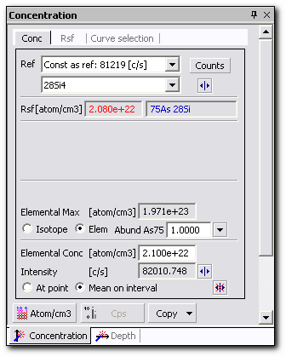
Figure 53. Concentration calibration panel: concentration method.

Concentration calibration Procedure for the Concentration method:
- Make the Curve to be processed the current Curve in the Species panel.
- Activate the Concentration panel.
- Select the Conc tab. The name of the selected Curve appears in blue in the RSF information box.
- Either use the Copy function to duplicate a former calibration process or chose from the Isotope or Element radio buttons. In the Element case, the Abundance pull-down menu appears. In this menu, it is possible to consult an isotope’s natural abundance, change this value manually or restore the default value.
- Enter the Concentration value and press the Enter key. The RSF value appears in red in the RSF field.
- Choose from the ‘At point’ or ‘Mean on interval’ radio buttons in the concentration part of the panel.
- Select the Cursor on mode by pressing the button. One or two green X cursors appear depending on the choice made.
- Drag the X cursors in the Graph window to define the interval [Xmin; Xmax] used to compute mean Intensity. The Elemental (or Isotopic) Max field is updated. The RSF value is also updated.
- Select the reference signal in the Ref pull-down menu (No, Point, Const as ref, Curve).
- Click Atom/cm³ button to execute Concentration calibration. The Graph window is updated. All concentration calibration parameters are saved in the Calibration list of Copy function.
- Click Cps button, if required, to restore the non calibrated Curve.
Contents

Dose Method
For this calibration method, the RSF is computed from known dose and the integrated number of detected ions of the Species of interest, with the relationship:
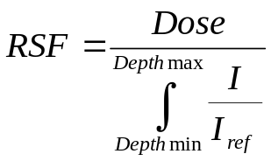

Operator makes the selection of the Reference signal.
In case of Dose calibration method, the dose of the element in the selected depth interval is known.
The Dose calibration method is only available if Depth calibration has already been done.

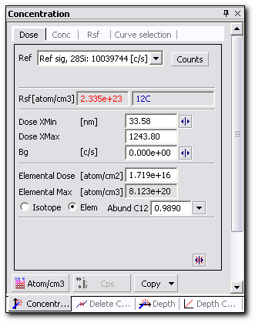
Figure 54. Concentration calibration panel: Dose method.
Concentration calibration Procedure for the Dose method:
- Make the Curve to be processed the current Curve in the Species panel.
- Activate the Concentration panel.
- Select the Conc tab. The names of the selected Curves appear in blue in the RSF information box.
- Either use the Copy function to duplicate a former calibration process or chose from the Isotope or Element radio buttons. In the Element case, the Abundance pull-down menu appears. In this menu, it is possible to consult an isotope’s natural abundance, change this value manually or restore the default value.
- Enter the Dose and press the Enter key. The RSF value appears in red in the RSF field.
- Press the Cursor on button for entering the Dose limits. Two green X cursors appear.
- Enter the Dose limits corresponding to the low and high X cursors by dragging the X cursors in the Graph window. The Elemental (or Isotopic) Max is updated. The RSF value is also updated.
- Press the Cursor on button to enter the Background limit. One horizontal green cursor appears.
- Enter the Background value by dragging the Y cursor in the Graph window. The Elemental (or Isotopic) Max is updated. The RSF value is also updated.
- Select the reference signal in the Ref pull-down menu (No, Point, Const as ref, Curve).
- Click Atom/cm³ button to execute Concentration calibration. The Graph window is updated. All concentration calibration parameters are saved in the Calibration list of Copy function.
- Click Cps button, if required, to restore the non calibrated Curve.
Contents

Multilayer Concentration Calibration
The Multilayer concentration calibration function is no different from the Monolayer calibration. Pressing the button should lead to concentration calibration of the selected Curve through layer structure. Every layer previously determined with the Multilayer Depth calibration procedure should have its own RSF value entered and Reference method selected. First, operator determines RSF value in every layer and then the RSF value along with chosen Reference method will be applied for whole Curve.
Each layer is considered as a monolayer. All other procedures mentioned above are available in Multilayer mode, except for the Dose method. The calibration parameters must be defined in every layer before carrying out the calibration. Both Concentration and RSF methods can be combined for the same Curve in different layers.
Contents

Processing Panel
The Processing panel gives access to the following functions:
  - Normalization
  - Scaling Factor
  - Background Subtraction
  - Statistics
  - Smoothing
  - Linear Combination
  - Data Point Removal
  - Derivative
  - Integration
  - Interpolation
  - Fitting
  - Decay X
  - Layer Width (Peak Width)
  - X Shift
  - Abundance Sensibility

The Processing function tab is placed at the bottom of the Processing panel. The current Processing function tab has a dark grey background.
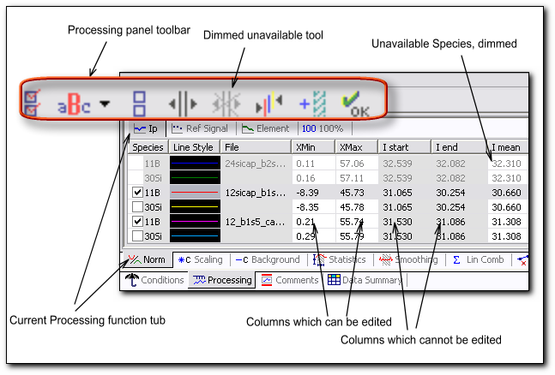
Figure 55. Processing panel.
The Processing panel has its own toolbar which depends on the current Processing function. All unavailable tools are dimmed. This way you can easily see which tools may be used. The columns which can be user edited have a white background and consequently those with the grey background can not be changed by the user. Species which are not selected in the Species panel are not shown in the Graph window and thus can not be processed or used in the data processing; their parameters are unavailable for editing.
It is possible to remove a Curve from the Processing panel with the aid of the pop-up menu which appears by right-clicking on the corresponding Specie. The procedure is the same as for deleting from the Species panel. The Curves may also be deleted from the Delete panel.

Processing Tools:
The select status ( = yes, = no) defines the Curves to be processed with the current parameter values. Only the Curves which have a visible status in the Species panel may be selected. Their names appear in black.
The Select All button sets a ‘yes’ select status for all Curves already selected in the Species panel.
The Select Species pull-down button opens a pull-down menu from which it is possible to choose a Specie of a certain type; whereupon all opened Species of that type are selected.
The Deselect All button sets a ‘no’ select status for all Curves of the Processing panel.
The Show X Limits button sets the X intervals for all Curves selected in the Processing panel.
After clicking the X Limits button, the X Limits zone appears in the Graph window and you can change it by dragging the X Limits with your mouse. The X Limits fill the zone to which the processing function will apply. By clicking this button, the X Limits are set individually for each Curve. The color of the X Limits is the same as that of the Curve which they mark. The X Limits can overlap or be separate from each other for different Curves.
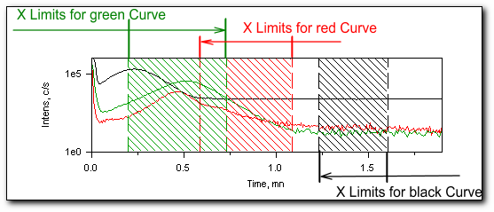
Figure 56. The X Limits set for each Curve separately.
The Hide Limits button hides all X and Y intervals in the Graph window.
The Unified Limits button sets the same interval for all Curves selected in the Processing panel.
After clicking the Unified Limits button, the X Limits zone appears in the Graph window. By clicking this button, the X Limits are set together for all the Curves loaded in the Graph window. When you change the X Limits by dragging them with the mouse, you change all X Limits together.
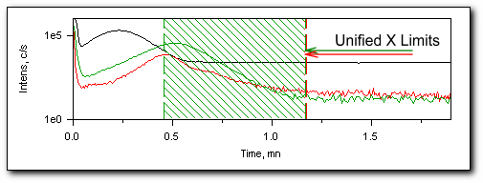
Figure 57. Unified X Limits.
The Show Background Limit button sets the background value.
The Copy to Clipboard button sends the checked rows from the Processing table to the clipboard.
The Default button is only used for the Layer Width (Peak) function. It finds an abscissa with the corresponding maximum ordinate.
The X Limits for Norm Value button shows the X limits which will be used to define a certain value to be used in processing. (These limits are shaded in another direction than that taken for the X Limits).
After clicking the X Limits for Norm Value button, the pull-down menu sign appears to the right side of the Show X Limits button. From this pull-down menu you can choose the limits to be shown in the Graph window: processing limits or the X Limits for Norm Value to be applied in a processing procedure. If you choose the X Limits for Norm Value from this menu, then these X Limits fill the zone in which calculation of the required value will be done. This zone is shaded slantingly to the right. You can change it, once it has appeared in the Graph window, by dragging the X Limits with your mouse or by entering the desired value directly into the processing table.
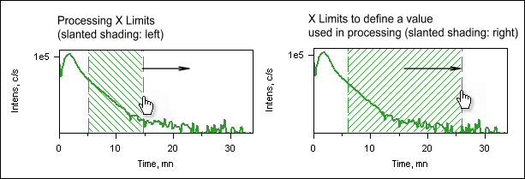
Figure 58. The X Limits for processing and for Normalization Value.
The X Limits for Norm Value button hides the X limits for Norm Value.
The OK button executes the Processing function.
Every Processing function has its own Processing table with different amounts and kinds of column. The first three columns are always Species name, Line Style, File name and the last one is always the History column.
Contents

History
The History column shows the number of times Processing has been applied to the Curve and lets you jump to any state of the Curve created during the Curve Processing. In that column the number to the left is the total number of times Processing was applied to the current Curve and the number to the right is equal to the amount of times the Undo function has been applied to the Curve. The title of the Processing last applied is shown in the History column. The quantity Processing which can be applied is quasi-unlimited.
The Undo function lets you revert to a previous state of a Curve. For every Curve, a list of applied Processing and their characteristics may be consulted by opening the pull-down menu in the History cell.
  - Each time you apply a change to a Curve, the new state of that Curve is added to the History pull-down menu.
  - The Processing is listed in a reverse order: the last Processing is at the top of the list and the raw data level is always at the bottom.
  - Processing can be undone one by one starting from the last Processing of the list.
  - Each state is listed with the title and parameters of the Processing used to change the Curve.
  - Selecting a state and then changing the Curve by the Undo function eliminates all states that come after.
  - You can use the Redo function to undo the last change and restore the previous state.

An example of a Processing list is shown in the figure below:
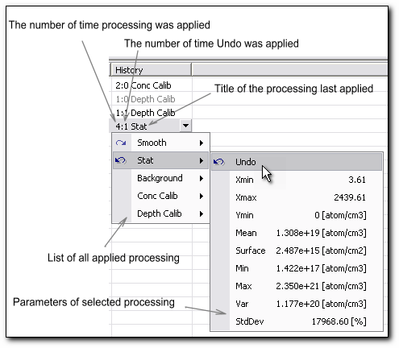
Figure 59. Processing History pull-down menu.

Procedure to apply Undo function:
- Activate the Processing panel.
- Make sure that the Curve to be restored has a visible status in the Species panel.
- Click the left mouse button to open pull-down menu list of the executed Processing.
- Click the left mouse button to open the Undo pull-down menu relative to the Curve to be restored in a former status.
- Click Undo for the Processing to be undone in the list.

By coupling several Undo procedures it is possible to go back step by step in the Processing list and the Curve will revert to how it looked when that change was first applied. You can then work from that state. When you select a state and change the Curve, applying any Processing, all states that come after the selected one will be deleted

Contents

Normalization
There are four different Normalizations of the measured secondary ion intensities:
  - Normalization by the primary beam intensity.
  - Normalization by the Reference Signal measured at the end of a given analysis.
  - Normalization point to point by the intensity measured for another Species during a given analysis.
  - Normalization of all selected Curves to 100%.

Ip Normalization
This function normalizes the secondary ion intensity by the primary beam intensity and produces a new Curve with the name curve_nmIp. This new Curve is plotted in the Graph window. It is used to correct the secondary ion intensities of the primary beam intensity drift which might occur at an analysis time.
This function is useful for measurements in which the primary beam intensity is measured before starting the analysis and at the end of the analysis (CAMECA IMS 6f). It is assumed that the primary beam intensity varies linearly as a function of time.
Note that for the last generation CAMECA instruments – IMS WF and IMS 7F - the primary beam intensity is measured during the analysis in situ; therefore the Normalization of the secondary ion intensity by the primary beam intensity is performed the same way as using the Element Normalization function by default.
The Normalization is carried out according to the relationships:
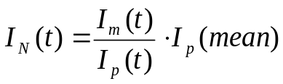
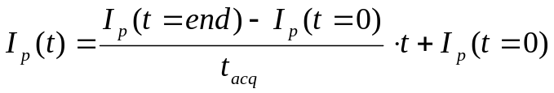
where:
In (t) is equal to the normalized intensity of the data point acquired at the time t.
I_{m} (t) is equal to the measured intensity of the data point acquired at the time t.
I_{p} (t=0) is equal to the primary beam intensity measured before starting the analysis.
I_{p} (t=end) is equal to the primary beam intensity measured at the end of the analysis Ip.
I_{p} (mean) is equal to the mean primary beam intensity computed from Ip(t=0) and I_{p}(t=end).
I_{p} (t) is equal to the computed primary beam intensity at the time t.

By default, the I_{p} (mean) value is defined in the same interval to which the processing is applied. This interval can also be defined by the independent limits setting. By using the X Limits for Norm Value button, you can change this interval.

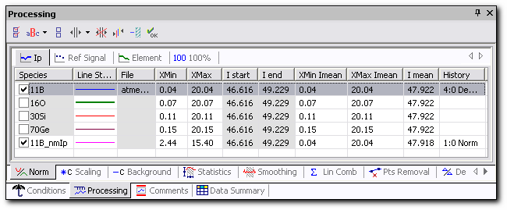
Figure 60. Processing panel: Ip Normalization.
Procedure to apply Ip Normalization:
- Activate Processing panel and then the Norm tab and the Ip tab.
- Set select status for the Curves to be processed.
- Set the X Limits for the selected Curves by using either the keyboard or the cursor in the Graph window.
  - If desiring to use the independent limits setting for calculation the I_{p} (mean) value, press the X Limits for Norm Value button. The pull-down menu sign appears near the Show X Limits button.
  - Open this pull-down menu and click on the Norm value limit item. An area slantingly shaded to the right appears in the Graph window.
  - Set the Norm value X Limits by using the cursor in the Graph window. The I_{p} (mean) will be calculated in the interval [XMin Imean, XMax Imean].
- Click OK to execute Ip Normalization. The Curve with the name curve_nmIp appears in the Processing panel and in the Species panel. The new Curve will be visible in the Graph window.
Otherwise, you can set the Limits for Normalization value by typing the desired value directly in the processing table cells XMin Imean, XMax Imean.

When the Ip Normalization is applied to the Curves, the Y Axis the data units remain unchanged. The Ip Normalization can be applied to any type of analysis (depth profiles, mass spectra...).

Contents

Reference Signal Normalization
This function normalizes the secondary ion intensities measured for a Species by the secondary intensity measured at the end the analysis. A new Curve with the name curve_nmRefSig is produced and plotted in the Graph window.
The Normalization is carried out according to the relationship:
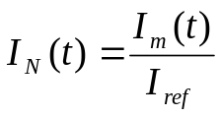
where:
In (t) is equal to the normalized intensity of the data point acquired at the time t.
Im (t) is equal to the measured intensity of the data point acquired at the time t.
Iref is equal to the secondary ion intensity measured for the reference species at the end of the analysis.
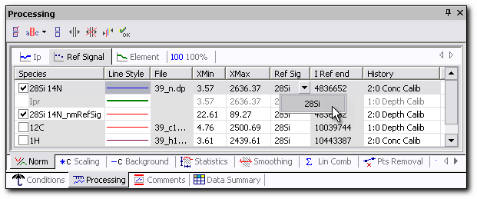
Figure 61. Processing panel: Reference Signal Normalization.
Procedure to apply Reference Signal Normalization:
- Activate Processing panel and then the Norm tab and Ref Signal tab.
- Set select status for the Curves to be processed.
- Set the X Limits for the selected Curves by using either the keyboard or the cursor in the Graph window.
- Select the Reference Signal from pull-down menu.
- Click OK to execute Reference Signal Normalization. The Curve with the name curve_nmRefSig appears in the Processing panel and in the Species panel. The new Curve will be visible in the Graph window.
When a Curve is normalized by a Reference Signal, the Y Axis associated to the Curve becomes adimensional (Adim).

Contents

Reference Element Normalization
This function executes the point to point normalization of secondary ion intensity measured for a Species by the secondary ion intensity measured for another Species. A new Curve with the name curve_’massElem’_nmElem is produced and plotted in the Graph window.
This function can also be used to normalize the secondary ion intensities by the primary beam intensity for data created in CAMECA IMS WF and 7F instruments, since in these instruments the continuous primary beam current measurement is performed in-situ.
The Normalization is carried out according to the relationships:
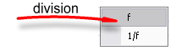
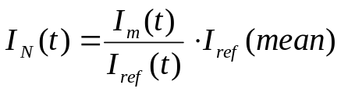
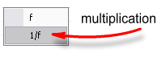
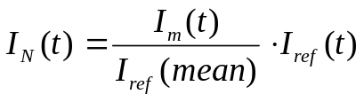
where:
I_{N} (t) is equal to the normalized intensity of the data point acquired at the time t.
I_{m} (t) is equal to the measured intensity of the data point acquired at the time t.
I_{ref} (t) is equal to the secondary ion intensity for the reference species linearly extrapolated at the time t from the reference species data points measured just before and after t.
I_{ref} (mean) is equal to the mean value of the secondary intensities measured for the reference species.

By default, the I_{ref} (mean) value is determined in the same interval to which the normalization is applied. This interval can be defined by the independent limits setting. By using the X Limits for Norm Value button, you can change this interval.

The Reference Element and the Curve to be normalized can belong to the different data files.
The mean value of the reference species I_{ref} (mean) can be read in the process list of the Undo pull-down menu where the Curve has been normalized.
When a Curve is normalized by a reference Specie, the units of the Y Axis associated to the Curve remain unchanged.

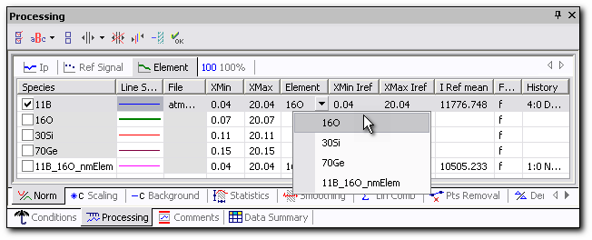
Figure 62. Processing panel: Reference Element Normalization.

Procedure to apply Reference Element Normalization:
- Activate Processing panel and then the Norm tab and Element tab.
- Set select status for the Curves to be processed.
- Set the X Limits for the selected Curves by using either the keyboard or the cursor in the Graph window.
  - If desiring to use the independent limits setting for calculation the I_{ref} (mean) value, press the X Limits for Norm Value button. The pull-down menu sign appears near the Show X Limits button.
  - Open this pull-down menu and click on the Norm value limit item. An area slantingly shaded to the right appears in the Graph window.
  - Select the Reference Species from pull-down Element menu. I Ref mean value appears.
  - Set the Norm value X Limits by using the cursor in the Graph window. The I_{ref} (mean) will be recalculated in the interval [XMin Iref, XMax Iref].
- Select the function from pull-down menu: f (division) or 1/f (multiplication).
- Click OK to execute Reference Element Normalization. The Curve with the name curve_’massElem’_nmElem appears in the Processing panel and in the Species panel. The new Curve will be visible in the Graph window.

Contents

100% Normalization
This function normalizes the secondary ion intensities measured for a Specie in order to have the data point with the maximum intensity arbitrarily set at Y = 100 or at Y=1. A new Curve with the name curve_nm100 or curve_nm1 is produced and plotted in the Graph window.
The normalization is carried out according to the relationship:
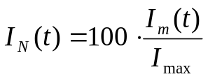
where:
I_{n} (t) is equal to the normalized intensity of the data point acquired at the time t.
I_{m} (t) is equal to the measured intensity of the data point acquired at the time t.
I_{max} is equal to the maximum intensity measured for the species to be normalized.

By default, the I_{max} value is determined in the same interval to which the normalization is applied. This interval can be defined by the independent limits setting. By using the X Limits for Norm Value button, you can change this interval.

When a Curve is normalized by 100%, the Y Axis associated with the Curve becomes adimensional (Adim).
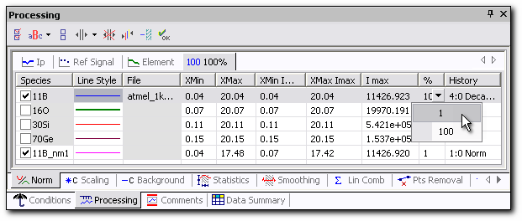
Figure 63. Processing panel: 100% Normalization.

Procedure to apply 100% Normalization:
- Activate Processing panel and then the Norm tab and 100% tab.
- Set select status for the Curves to be processed.
- Set the X Limits for the selected Curves by using either the keyboard or the cursor in the Graph window.
  - If desiring to use the independent limits setting for calculation the I_{max} value, press the X Limits for Norm Value button. The pull-down menu sign appears near the Show X Limits button.
  - Open this pull-down menu and click on the Norm value limit item. An area slantingly shaded to the right appears in the Graph window.
  - Set the Norm value X Limits by using the cursor in the Graph window. The I_{max} will be recalculated in the interval [XMin Imax, XMax Imax].
- Select the percent of Normalization from pull-down % menu. You can choose 100 or 1.
- Click OK to execute 100% Normalization. The Curve with the name curve_nm100(or 1) appears in the Processing panel and in the Species panel. The new Curve will be visible in the Graph window.
Contents

Scaling
This function multiplies every data point of a Curve by a constant value defined by the operator. The Scaling factor can be applied within an interval defined by the operator.
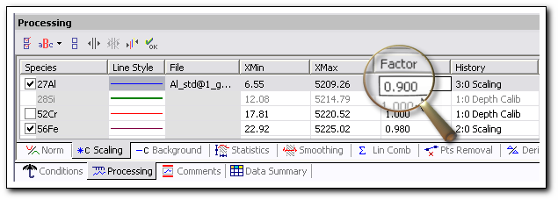
Figure 64. Processing panel: C Scaling.
Procedure to apply the Scaling factor:
- Activate Processing panel and then the C Scaling tab.
- Set select status for the Curves to be processed.
- Set the X Limits for the selected Curves by using either the keyboard or the cursor in the Graph window.
- Enter the Scaling factor values for the selected Curves by using the keyboard.
- Click OK to apply the Scaling factor.
Contents

Background Subtractions
This function subtracts a constant value from the Curves selected by the operator. The constant value is defined by the operator. The Background subtraction may be applied within an interval defined by the operator.
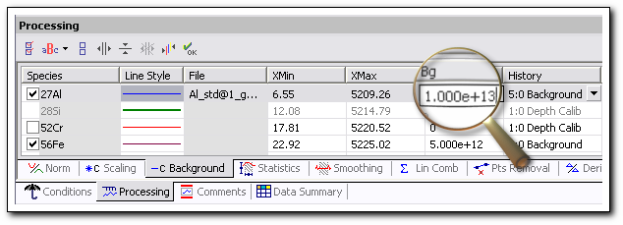
Figure 65. Processing panel: Background Subtraction.

Procedure to apply Background subtraction:
- Activate Processing panel and then the C Background tab.
- Set select status for the Curves to be processed.
- Set the X Limits for the selected Curves by using either the keyboard or the cursor in the Graph window.
- Enter the background value for the selected Curves by using either the Show Background Limit toolbar button or the keyboard.
- Click OK to execute the Background subtractions.

Subtracting a negative Background value is not prohibited. In this case, the resulting Curve will be produced by adding a constant positive value to the selected Curve.

Contents

Statistics
This function computes and shows the main statistical parameters in the selected interval for the selected Species. After applying the Statistics procedure, the Statistics parameters are displayed in the Processing panel table:
- Mean. The mean of the Y values.
- Surface. The integral of the Curve.
- Min. The minimum of the Y values.
- Max. The maximum of the Y values.
- StdDev. The standard deviation of the Y values:
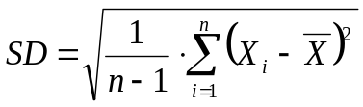, where is the X mean.
- Var. The overall variation of Y values:
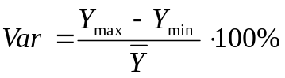 , where is the Y mean.
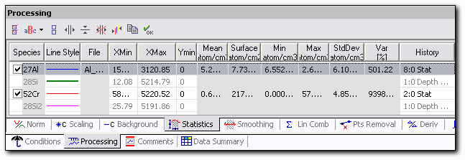
Figure 66. Processing panel: Statistics.
Procedure to calculate the Statistic parameters:
- Activate the Processing panel, then the Statistics tab.
- Set select status for the Curves to be processed.
- Set the X Limits as well as a background value for the selected Curves by using either the keyboard or the cursor in the Graph window.
- Click OK to calculate the Statistic parameters.
You can export the calculated Statistic parameters through the clipboard into any electronic spreadsheet program or office application by clicking on the ‘Copy to Clipboard’ button on the processing toolbar.

Contents

Smoothing
This function applies a Smoothing procedure on the Curves selected by the operator. It allows a partial smoothing of the Curve over an interval defined by the operator.
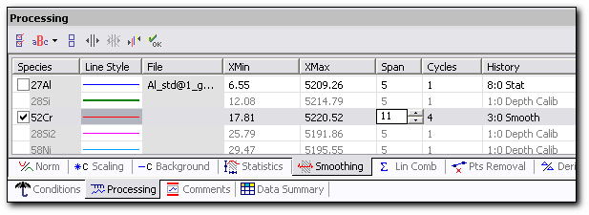
Figure 67. Processing panel: Smoothing.

The smoothing level may be controlled by the operator with the aid of the following adjustable parameters:
  - Span: it is the number of data points involved in the Smoothing procedure of the Curve in the defined interval. It always has an odd value. For instance a Span value of 9 means that the intensity of every data point of the smoothed Curve is a linear combination of the intensity of the point itself, the 4 former points and the 4 next points. Each point of the linear combination is affected by a coefficient listed in the table below. The Span value can be adjusted between 5 and 25.
  - Cycle: it is the number of times that the smoothing is repeated with the same span parameter. The maximum number of cycles is 9.

Smoothing coefficient table
(from Numerical Recipes, Cambridge University Press)
 | Point #
Span | 0 | ± 1 | ± 2 | ± 3 | ± 4 | ± 5 | ± 6 | ± 7 | ± 8 | ± 9 | ± 10 | ± 11 | ± 12
5 | 17 | 12 | -3
7 | 7 | 6 | 3 | -2
9 | 59 | 54 | 39 | 14 | -21
11 | 89 | 84 | 69 | 44 | 9 | -36
13 | 25 | 24 | 21 | 16 | 9 | 0 | -11
15 | 167 | 162 | 147 | 122 | 87 | 42 | -13 | 78
17 | 43 | 42 | 39 | 34 | 27 | 18 | 7 | -6 | -21
19 | 269 | 264 | 249 | 224 | 189 | 144 | 89 | 24 | -51 | -136
21 | 329 | 324 | 309 | 284 | 249 | 204 | 149 | 84 | 9 | -76 | -171
23 | 79 | 78 | 75 | 70 | 63 | 54 | 43 | 30 | 15 | -2 | -21 | -42
25 | 467 | 462 | 447 | 422 | 387 | 322 | 287 | 2222 | 147 | 62 | -33 | -138 | -253

Smoothing Procedure:
- Activate Processing panel and then the Smoothing tab.
- Set select status for the Curves to be processed.
- Enter the Span value and the Cycle number for the Curves by clicking on the corresponding spin buttons.
- Enter the low (Xmin) and high (Xmax) abscissa limits by using the keyboard or the cursor in the Graph window.
- Click OK to execute the Smoothing.
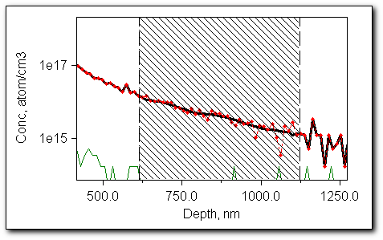
Figure 68. Graph window: Smoothing.
Contents

Linear Combination
This function computes the new Curve which is the result of the linear combination of the selected Curves. The intensity the k^{th} point of the resulted Curve is given by the following formula:
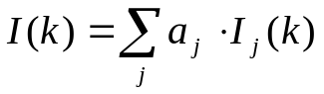
where :
I_{j} (k) is the intensity of the considered Curve at point k,
a_{i} is a real number.
The new Curve with the name Curve₁Curve₁…_comb appears in the Species panel and in the Graph window.
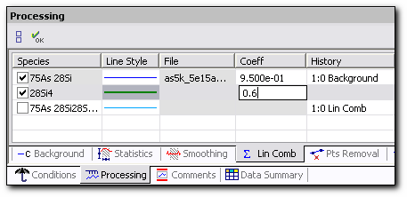
Figure 69. Processing panel: Linear combination.

Procedure to compute Linear Combination:
- Activate Processing panel and then the Lin comb tab.
- Set select status for the Curves to be processed.
- Enter the linear coefficients.
- Click OK to perform Linear combination.
Contents

Data Points Removal
This function removes or substitutes the data points over an interval defined by the operator. Every removed data point is replaced point by point with a new ordinate computed either by interpolation derived from the data points outside the interval or by a fitting function. Different algorithms of interpolation can be used: linear, quadratic spline, cubic spline, Lagrange polynomial, Newton polynomial and Neuville-Aitken polynomial. The same fitting functions are used as in the Fitting processing panel.
The interval is defined by the Xmin and Xmax parameters. Xmin and Xmax are included in the interval. Using either the keyboard or the cursor in the Graph window, you can enter the high and low limits of the interval. The point replacements are performed in two parts:
- Choosing the type of interpolation by trying the different interpolation algorithms.
- Performing the interpolation and point replacements.
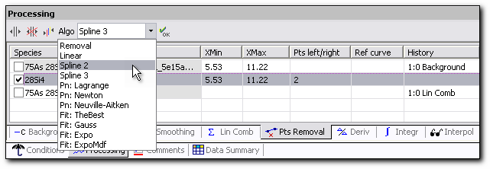
Figure 70. Processing panel: Point Removal. Choosing the interpolation method.
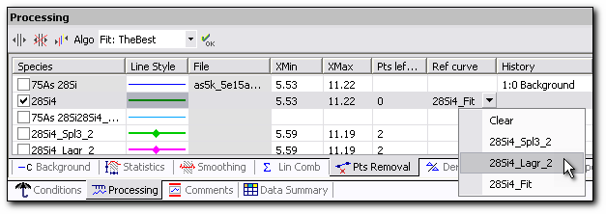
Figure 71. Processing panel: Point Removal. Performing the interpolation.
Procedure for Data Points Removal:
- Activate Processing panel and then the Pts removal tab.
- Set select status for the Curves to be processed.
- Set the X Limits for the selected Curves by using either the keyboard or the cursor in the Graph window.
- Select the interpolation algorithm from the ‘Algo’ pull-down menu.
- Select the number of points on the sides of the chosen interval by pressing the spin button on the ‘Pts left/right’ column.
- Click OK to calculate the interpolation Curve. A Curve with the name curve_AlgorithmName appears in the Processing panel, in the Species panel and also in the ‘Ref curve’ column in the Processing table. The new Curve will be visible in the Graph window.
- Repeat steps 4 to 6 for different interpolation algorithms to define the best algorithm.
- Select the more suitable interpolation Curve from the ‘Ref curve’ pull-down menu.
- Click OK to perform Points Removal. The points of the chosen interpolated Curve replace the corresponding points of the original Curve and all reference Curves with the names curve_AlgorithmName are deleted.
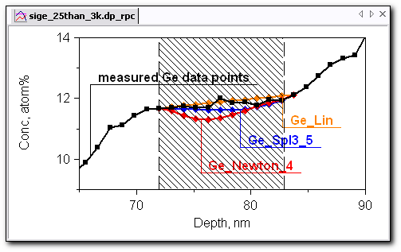
Figure 72. Graph window: Interpolation Curves for Points Removal.
The algorithm with the name ‘Removal’ simply removes all the points from the selected interval. It is performed in one mouse click.
Contents

Derivative
This function computes the first Derivative function of the selected Curve and produces a new Curve with the name curve_derived. The name of the new Curve appears at the Species and Processing panels. This new Curve is plotted in the Graph window and a new ordinate Axis possessing its own units appears.
Before applying the Derivative function, it may be useful to apply the Smoothing procedure to the Curve to be processed.
By chaining several Derivative function executions, it is possible to compute the second, third... Derivative of the source Curve.
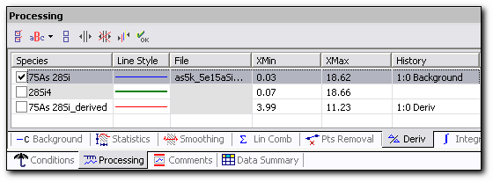
Figure 73. Processing panel: Derivative.
Procedure to compute Derivative Curve:
- Activate the Processing panel, then the Deriv tab.
- Set select status for the Curves to be processed.
- Set the X Limits for the selected Curves by using either the keyboard or the cursor in the Graph window.
- Click OK to compute the Derivative Curves.
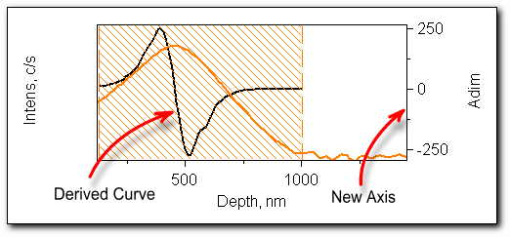
Figure 74. Graph window: Derivative.
If the measurement units of the derived Curve have physical significance, an Axis with its own dimensions is added to the Graph window. For example, applying the time Derivative to the Depth Curve or to the Depth_calib Curve gives the Curve with the Sputter rate dimensions. A new SR Axis appears in this case.
Contents

Integration
This function computes the Integral Function of the selected Curve and produces a new Curve with the name curve_integr. When the Integral function is applied, a new Curve appears at the bottom of the Species panel and in the Processing panel. This new Curve is plotted in the Graph window and a new ordinate Axis possessing its own units appears.
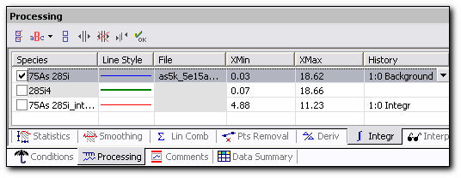
Figure 75. Processing panel: Integral.

Procedure to compute Integral Curve:
- Activate Processing panel and then the Integr tab.
- Set select status for the Curves to be processed.
- Set the X Limits for the selected Curves by using either the keyboard or the cursor in the Graph window.
- Click OK to compute the Integral Curves.

If the measurement units of the integrated Curve have physical significance, an Axis with its own dimensions is added to the Graph window. For example, applying a depth Integral to a Curve calibrated in concentration produces a Curve with Dose dimensions. A new Dose Axis appears in this case. This example is illustrated in the figure below.
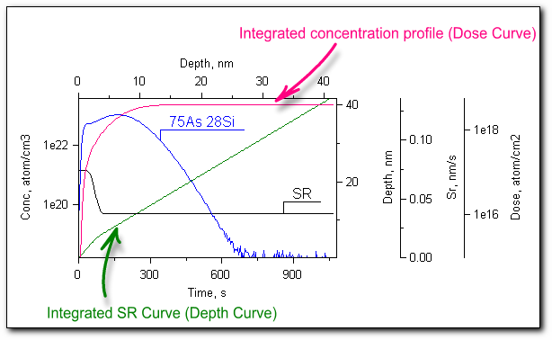
Figure 76. Graph window: applied Integral function with the new generated Axes.
Contents

Interpolation
This function adds additional points between the measured points of the Curve. The function allows increasing the number of points in the selected interval as well as reducing it and performs an Interpolation in this interval. There is a choice of two interpolation types: linear interpolation and cubic spline interpolation. A Curve with the new name curve_ipl_ AlgorithmName is produced. It appears in the Graph window and in the Species and Processing panels.
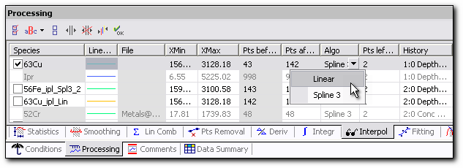
Figure 77. Processing panel: Interpolation.
Procedure to perform Interpolation:
- Activate Processing panel and then the Interpol tab.
- Set select status for the Curves to be processed.
- Set the X Limits for the selected Curves by using either the keyboard or the cursor in the Graph window.
- Enter the number of points on the ‘Pts after’ column. This amount of points will appear in the selected interval after applying the Interpolation.
- Select the interpolation algorithm from the pull-down menu in the ‘Algo’ column.
- Select the number of points on the sides of the chosen interval by pressing the spin button on the ‘Pts left/right’ column.
- Click OK to calculate the interpolation Curve. The Curve with the name curve_ipl_AlgorithmName appears in the Processing panel and in the Species panel. The new Curve will be visible in the Graph window.
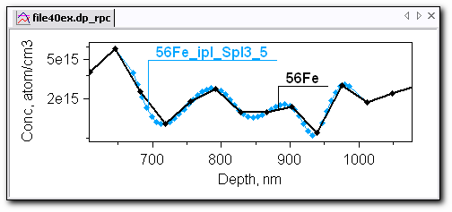
Figure 78. Graph window: Measured data and interpolation Curve for Interpolation processing.
Contents

Fitting
This function creates a Curve, which fits to any selected Specie data points accordingly to its fitting expression. There is a choice of four fitting function types: Gaussian, exponential, exponential modified and the best possible fitting.
A Curve with the new name curve_fit_ AlgorithmName is produced. It appears in the Graph window and in the Species and Processing panels.
The fitting processing is accomplished in two stages: 1) the definition of fitting parameters, 2) performance of the fitting procedure with the previously obtained parameters.
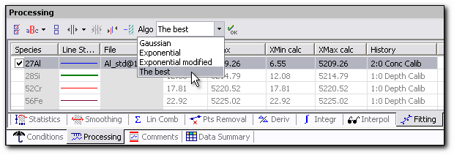
Figure 79. Processing panel: Fitting.
Procedure to perform Fitting:
- Activate the Processing panel and then the Fitting tab.
- Set select status for the Curves to be processed.
- Set the X Limits for the selected Curves by using either the keyboard or the cursor in the Graph window.
- Select the fitting algorithm from the pull-down menu in the ‘Algo’ column.
  - If desiring to use the independent limits setting, set the X Limits for calculation of the fitting parameters. For this, press the X Limits for Norm Value button. The pull-down menu sign appears near the Show X Limits button.
  - Open this pull-down menu and click on the Calculation limit item. An area slantingly shaded to the right appears in the Graph window.
  - Set the Calculation X Limits by using the cursor in the Graph window. The fitting function will be calculated in the interval [XMin calc, XMax calc].
- Click OK to calculate the fitting Curve. This Curve will be defined in the processing limit interval [XMin, XMax]. A Curve with the name curve_fit_AlgorithmName appears in the Processing panel and in the Species panel. The new Curve will be visible in the Graph window.
The parameters of the fitting function appear in the History column.

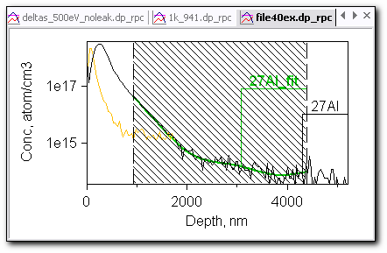
Figure 80. Graph window: Measured data and fitting Curve for Fitting processing.
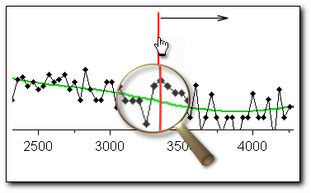
Figure 81. The X Cursor scanning along the fitting Curve.
The fitting function may be useful for scanning along the Curve with the X Cursor. Instead of noisy data the sliding cursor gives monotonous changing values.
Contents

Decay X
This function calculates the interval X which corresponds to the intensity increment for one decade. The units of the decay X are time/decade, length/decade, and mass/decade.
The value of the decay X is computed from two points defined by the operator- (X1,Y1) and (X2,Y2):
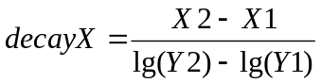, where X2>X1
The decay X value can be negative or positive in accordance to the Curve slope between two points.
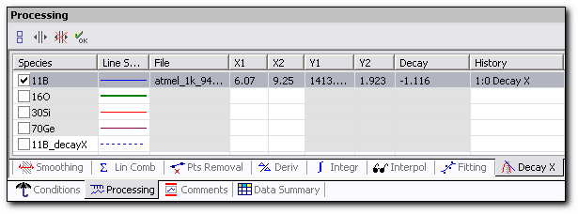
Figure 82.Processing panel: Decay X.
Procedure to compute Decay X:
- Activate the Processing panel and then the Decay X tab.
- Set select status for the Curve to be processed.
- Click the ‘Show X Limits’ toolbar button. A dashed line appears in the Graph window and the name curve_decayX appears in the Species list.
- Set the X Limits for the selected Curve by using either the keyboard or dragging the cursor in the Graph window.
- Repeat steps 2 to 4 for other Curves if required.
- Click OK to perform Decay X.
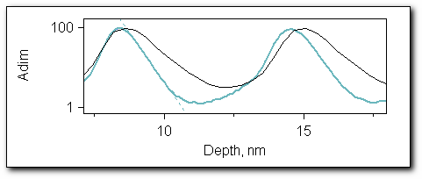
Figure 83. Graph window: Decay X.

The Curve with the name curve_decayX is deleted after the performance of the Decay X procedure.

Contents

Layer Width
This function computes the width of the selected Curve on a chosen height. This height is defined by the ‘Height Ratio’ and equal to: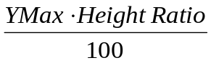. The Layer Width = XLeft- XRight.
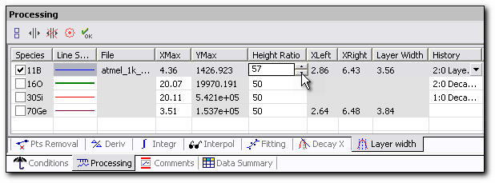
Figure 84. Processing panel: Layer Width.

Procedure to compute Layer Width:
- Activate the Processing panel and then the Layer width tab.
- Set select status for the Curve to be processed.
- Click the ‘Show X Limits’ toolbar button. On doing so, the middle of the highest point is marked with the X Limits.
- Set the ‘Height ratio’ by scrolling the spin button. By default the height ratio is set to 50%.
- Repeat steps 2 to 5 for other Curves if required.
- Click OK to perform Layer Width.
Contents

Peak Width
The Peak Width function replaces the Layer Width function for the all analysis type data other than depth profile data. This is a similar function, but for mass spectrum and high mass resolution analysis type it computes the mass resolution value.
This function computes the width of the selected peak on a chosen height. This height is defined by the ‘Height Ratio’ and equal to: 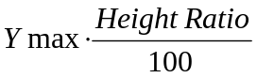 . The Peak Width = XLeft- XRight.
WinCurve program helps choose a peak. When you move the cursor across the X Axis in an area where there is no local peak, you see only one cursor marker; when you approach a local peak, the cursor marker becomes surrounded by two other markers, XMin and XMax.
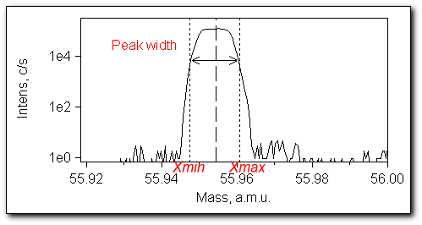
Figure 85. Labeled peak limits in the Graph window for the Peak Width procedure.
Procedure to compute Peak Width:
- Activate the Processing panel, then the Peak width tab.
- Set select status for the Curve to be processed.
- Click the ‘Show X Limits’ toolbar button. On doing so, the middle of the highest peak is marked with the X Limits.
- Grab the middle peak selection and move it to another peak if required.
- Set the ‘Height ratio’ by scrolling the spin button. By default, the height ratio is set to 50%.
- Repeat steps 2 to 5 for other Curves if required.
- Click OK to perform Peak Width.
You can click the ‘Default’ toolbar button to return to the selection of the highest peak of the Curve.

If you set the ‘Height ratio’ too low and the program can not find corresponding XMin and XMax, then an alert window appears.

Contents

X Shift
This function moves the data along the X Axis. This function applies to all analysis data types except for depth profile data.
Procedure to compute X Shift:
- Activate the Processing panel, then the X Shift tab.
- Set select status for the Curve to be processed.
- Enter the Shift value by keyboard.
- Click OK to perform X Shift.
Contents

Abundance Sensibility
This function applies only to the mass spectrum data. It computes the Abundance sensibility for the mass data according to the formula:
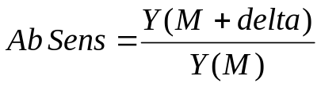
where:
M is the center of the mass peak;
Y(M) is the signal intensity in mass spectra point with coordinate M.
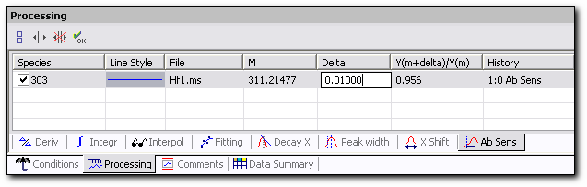
Figure 86. Processing panel: Abundance sensibility.

Procedure to compute Abundance Sensibility:
- Activate the Processing panel, then the Ab Sens tab.
- Set select status for the Curves to be processed.
- Click the ‘Show X Limits’ toolbar button. On doing so, two Y cursors appear: the dotted cursor marks the middle of the peak and the dashed cursor marks its distance Delta from the middle of the peak.
- Drag the middle peak selection and move it to the peak center or change its position with the keyboard by entering the desired value in the M column.
- Set the Delta position either by dragging the dashed X cursor in the Graph window or by using the keyboard. The Abundance sensibility column is updated. Default Delta value is 0.1.
- Click OK to perform Abundance sensibility.
Contents

Batch Processing Panel
The purpose of Batch processing is to perform automatic data processing. This function duplicates a sequence of processing applied to one file (recipe file) on a series of files selected by the operator. It is supposed to be applied to data with slight differences obtained in measurement series with similar analytical conditions.

Recipe File
The Recipe file for batch processing presents all processing as a list. This list includes the Graph window parameters: axis, units, labels; tables and also all processing applied to the recipe file. Every processing can be applied to the Curve on the full X range or only on the X interval. For each processed file a recipe file for batch processing with the extension filetype_brcp can be created. Usually this file is saved in the same directory as other processed files.
Procedure to make a recipe file for Batch processing:
- Open file.
- Implement the sequence of desired processing procedures.
- From the File menu choose the ‘Batch/Save Recipe As…’. The ‘Save Batch File’ file dialog box opens. This dialog box also has a recipe file preview area. It contains a list of performed processing with its main parameters. Every processing is located in chronological order in this list.
- Name the recipe file and then save it. The file extension is filetype_brcp.
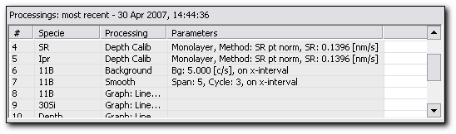
Figure 87. Recipe file preview with a list of applied processing.
Contents

Preparing Batch Execution
Once the recipe file is created, batch execution procedure can be prepared.
To open the Batch panel:
  - In the main menu, select File, Batch, Run Processing
or
  - Click the Batch tab on the stacked panel if it is present in the Workspace at the moment. By default, the Batch panel is presented in the panel group on the left side of the Workspace.
The Batch panel has two sections, each one under a different tab: the Recipe section and the Run section.
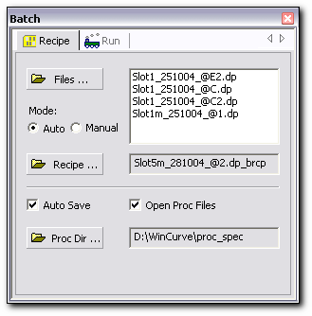
Figure 88.Batch Panel, Recipe tab.
The Batch/Recipe tab area contains:
- ‘Files…’ button. Opens the ‘Select Data Files’ dialog box. This dialog box presents a choice of files for batch processing.
- ‘Auto’/’Manual’ radio-buttons. Use them to toggle between the auto and manual processing modes.
- Files list area. Indicates the files chosen for batch processing.
- ‘Recipe…’ button. Opens the ‘Open Batch Files’ dialog box.
- ‘Recipe file’ textbox. Indicates the chosen recipe file.
- ‘Auto Save’ checkbox. Check it to save the batch processed files. The files are saved with the filetype_rpc extension.
- ‘Open Proc Files’ checkbox. Check it to open the batch processed files in the Graph window.
- ‘Proc Dir’ button. Opens the ‘Browse for folder’ dialog box. The batch processed files will be saved in this directory.
- ‘Proc Dir’ textbox. Indicates the directory into which the processed files are collected. This is the proc_spec directory by default.
Contents

Batch Execution
The files to be batch processed are raw data files of any analysis type. The recipe file and the files for batch processing accordingly have the same analysis type.
It is recommended to create a special batch layout and work in it when dealing with batch processing. The essential property of this layout should be that the Batch panel be a large floating panel over the Workspace. During batch execution in manual mode, every panel which is presented in the Processing column of the recipe file preview area will be activated. For this reason it is more convenient to have a floating Batch panel.
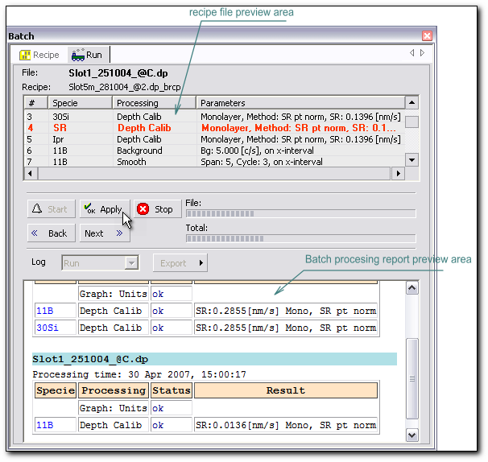
Figure 89. Batch Panel, Run tab.
The Batch/Run tab area contains:
- ‘File:’ label. Indicates the file which is currently processed.
- ‘Recipe:’ label. Indicates the chosen recipe file.
- Recipe file preview area. This is a table with four columns which contains the processing list. Every processing is located in chronological order in this list.
  - #. Shows the processing chronological number in the list.
  - Specie. Shows the Specie name to which the processing is being applied.
  - Processing. Indicates the processing name. The processing can be applied on the full X-range or only on the X-interval.
  - Parameters. Indicates the main parameters obtained in processing, if any.
- ‘Start’ button. Starts the batch processing sequence.
- ‘Apply’ button. Available only in manual mode. Press it to perform the selected procedure (selected in bold in the recipe file preview area).
- ‘Stop’ button. Stops the current processing.
- ‘Back/Next’ buttons. Available only in manual mode. Press them to go to the previous or to the following processing.
- ‘File/Total’ information areas. Indicate progress in the processing performance.
- ‘Log’ label with a pull-down menu. Choose between Batch Processing Log or Batch Data Summary report.
- ‘Export’ button. Use it for file manipulation with the Batch Data Summary.
- ‘Specie’ label with a pull-down menu. This is a filter for Species. From the pull-down menu, choose the desired Specie names. (Available only for Batch Data Summary report).
- Columns. Click this button to choose analytical conditions, calibration results and processing parameters which will be inserted into the Batch Data Summary report. They are presented in the report as columns with alternating colors. (Availably only for Batch Data Summary report).
Batch processing can be executed in auto or manual mode. Auto mode is the most commonly used. The manual mode gives the user possibilities to deviate from the prescribed processing order and customize the sequence of procedures.
In manual mode, the files for processing are loaded one by one consecutively and all operations have to be confirmed by the operator by pressing the ‘Apply’ button. The current processing is selected in bold in the recipe file preview area. The current processing in the Batch panel activates the corresponding processing panel or the Units, Label or Axis panels. It is possible to skip any processing step by pressing the ‘Next/Back’ buttons and also to change the processing parameters in this mode.
Procedure for Batch processing:
- Activate the Batch panel.
- Activate the ‘Recipe’ tab on top of the Batch panel.
- Press the ‘Files’ button. The ‘Select Data Files’ dialog box opens.
- Choose the files to be processed. Only raw data files can be chosen and all files for the same recipe have to be chosen at the same time. The list of files to be processed appears in the ‘Files’ textbox.
- Press the ‘Recipe’ button. The ‘Open Batch Files’ dialog box opens.
- Choose the recipe file to be processed. It has the extension filetype_brcp. Upon choosing such a file the recipe file preview becomes available along with the date and time of the most recently performed processing. After choosing the file, its name appears on the Batch panel.
- Select the Auto or Manual radio button.
Check or uncheck the Auto Save check box (for Auto mode only). Depending on this choice, the processed files will either be saved automatically with the name filename.filetype_rcp, or not.
- Check or uncheck the Open Proc Files check box (for Auto mode only). Depending on the choice, the processed files will either be opened in the Graph window or they will not.
- Press the ‘Proc Dir’ button and choose a directory for the processed files. By default, this is the proc_spec directory.
- Activate the ‘Run’ tab on top of the Batch panel.
- Press the ‘Start’ button to execute Batch processing. In Auto mode all sequences for all chosen files will be executed. In manual mode every operation has to be confirmed with the ‘Apply’ button.

Clicking the button during batch execution stops the Batch.

There is only one particularity for the execution of Batch processing in Auto mode. When the recipe file contains the Depth calibration in Crater mode, the operator has to enter the crater depth manually for every file in the list before launching the batch processing.
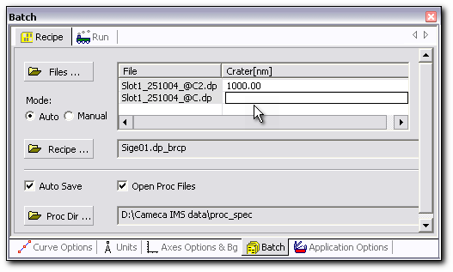
Figure 90. Manual crater depth entry for batch processing.

When performing the batch processing in manual mode, do not confirm the current step with the ‘OK’ button in the processing panel. Confirm the processing to be applied with the ‘Apply’ button in the Batch panel instead.

But there is one exception to this rule. To execute the batch which contains the Points Removal processing in manual mode, it is necessary to choose the point removal algorithm manually and confirm the choice by pressing the ‘OK’ button on the Points Removal processing panel. Only after that is it necessary to press the ‘Apply’ button on the Batch panel.
Contents

Report Generation during Batch Processing
There are two possible report presentations for the batch processing: the Batch processing Log and the Batch Processing Data Summary report.

Batch Processing Log
Upon the execution of batch processing, a Batch Processing Log is created. The Batch Processing Log has a heading with the processed file name and processing time and a Log table which contains information about the performed processing with its status and the main parameters obtained. In this Log all performed processing has an execution status which can be OK or error. The Result column of the Log either presents the reason of an error message or shows the main parameters obtained.
With the aid of the Export button it is possible to save the generated Batch Processing Log or place it on the clipboard for further use in different office applications or in the print function. The file for the Batch Processing Log has the extension datatype_bdt_sm.
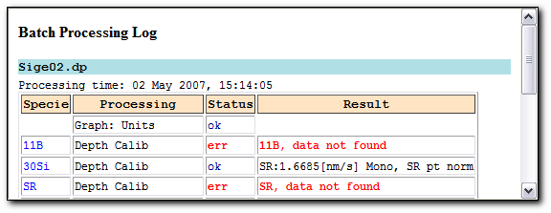
Figure 91. Batch Processing Log.
Contents

Batch Processing Data Summary Report
After performing batch processing, instead of obtaining a Batch processing Log it is possible to generate a Batch Processing Data Summary report. To do so, choose Data Summary from the Log pull-down menu.
For further manipulation with this report there are three possibilities for its export: print, copy to Clipboard for inserting into different office applications or save in a special format with the extension bdt_sm. The exported file filename.bdt_sm contains not only the columns selected in the report, but also all other data from the chosen processed files, such as information about all applied calibrations and processing parameters and also information about applied analytical and measurement conditions. Therefore, after loading the filename.bdt_sm file, the report presentation can be changed by choosing the different columns from the ‘Columns’ menu.
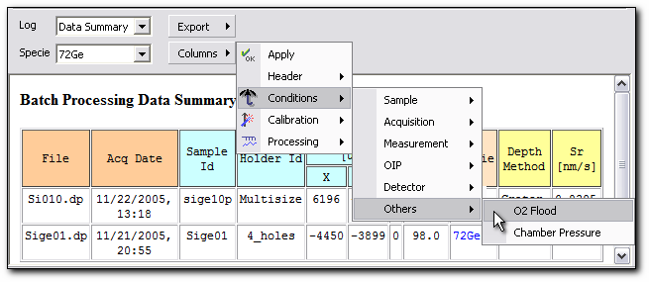
Figure 92. Batch Processing Data Summary.

Procedure to make the Batch Processing Data Summary report:
- Activate the Batch panel and select the Run tab at the top of the panel.
- Select the Data Summary from the Log pull-down menu.
- Choose All or one desired Specie from the Specie pull-down menu.
- Click the Columns button and check or uncheck the header, analytical conditions, calibration results and processing parameters to be presented in the report.
- Click the Columns button and then Apply to reformat the report view in the Batch Data Summary panel.
- Click Export and then choose from the Save As…, Copy to Clipboard or print commands. The saving of the Batch Data Summary report is performed in a special format with the extension bdt_sm.

The Batch Processing Data Summary Columns menu shares its appearance with the Columns menu of the Data Summary panel and with the menu command Edit-Report-Data Summary Columns.

Contents

Data Base Panel
The Data Base panel is used as a tool for working with the processed depth profile type samples database. Actually, there are two databases: the database for the calibration parameters SR and RSF, and the database for the reference samples. The main difference between the two databases is the fact that the reference sample database contains all information about any processed sample including the measured data file, but the SR/RSF database contains only detailed parameters of any measured and processed sample. The new IMS instrument comes with two empty database files crv_SrRsf.db and crv_Ref.db. By default these files are located in the …/CAMECA IMS data/setup directory. The database files are supposed to be filled by the user.
To open the Data Base panel:
  - In the main menu, select File, Data Base…
or
  - Click the Data Base tab on the stacked panel if it is present in the Workspace at the moment. By default, the Data Base panel is presented in the panel group on the right side of the Workspace.

Database Entry
Any processed file can be used to create a database entry. All fields filled in at a given time constitute an entry in the database. The fields with a white background can be edited like in the other panels of WinCurve. The fields with a grey background are filled in by the WinCurve program and cannot be changed. Analytical parameters that are introduced to the database entry automatically conserve their own format and precision.
The Data Base panel has three sections, each one under a different tab: the SR and RSF parts of a database, and the Reference sample database. The SR and RSF parts have the same interface while the Reference sample database is slightly different. To export data from WinCurve to the database and to make a database entry, it is necessary to activate the ‘Export’ tab.

Sputter Rate Part of Database
Each time a Depth calibration is carried out, the SR value is computed and then the SR database entry can be made. The Unified SR and the Sputter Yield are calculated automatically at the moment of the SR/Export tab activation.
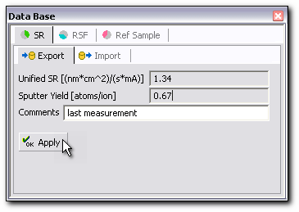
Figure 93. Data Base panel, SR/Export tab is used as the data entry.

An entry in the SR database includes:
  - Sputter Rate method and value.
  - Matrix name.
  - Unified form of Sputter Rate value:

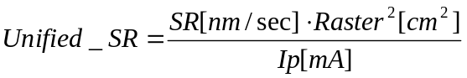; [(nm/sec)/(mA/cm²)]
This value can be compared with other entries, disregarding any differences in their analytical conditions.
  - Sputter Yield is calculated using known matrix density and the supposedly correct reading of the primary current and raster size:
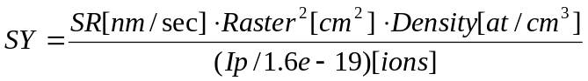; [atoms/ions]
Sputter Yield is a fundamental parameter of the sputtering process, it can be compared with one obtained on another SIMS instrument.
  - Comments.
  - Analytical measurement parameters. Available parameters are given in the Table below.
  - The file name.
  - The entry time.
Procedure to make an SR database entry:
- Make the Depth calibration of the desired file.
- Activate the Data Base panel.
- Activate the ‘SR’ tab and then the ‘Export’ tab at the top of the Data Base panel. The Unified Sputter Rate and the Sputter Yield are calculated and appear in the Data Base panel at this moment.
- Make comments in the ‘Comments’ field if needed.
- Press the ‘Apply’ button. The corresponding database entry is added to the database file. If the same database entry already exists then an information message appears.
Contents

RSF Part of Database
Each time a Concentration calibration is carried out, an RSF value is obtained and then an entry in the RSF database part can be made. The Useful Yield and the Normalized Useful Yield are calculated automatically at the moment of the RSF/Export tab activation.
An entry in the RSF database part includes:
  - Applied concentration calibration method with a reference signal value.
  - Specie and matrix names.
  - RSF normalized to natural abundance:

In the case of elemental RSF, it is normalized to the isotopic matrix signal.
  - RSF normalized to the matrix signal natural abundance:

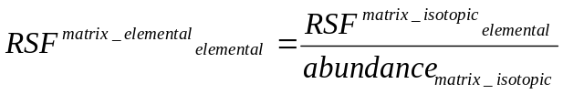
  - Useful Yield of element of interest is determined by the formula below (if the Depth calibration has already been made):

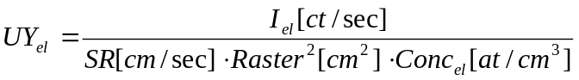
  - Normalized Useful Yield (if the Depth calibration has already been made):
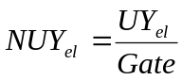,
where Gate is the calculated ion collecting area determined by either the optical gate or the electronic gate. It is calculated as:
Gate=Analysis Area²/Raster²
  - Comments.
  - Analytical measurement parameters. Available parameters are given in the Table below.
  - The file name.
  - The entry time.

Procedure to make an RSF database entry:
- Accomplish Concentration calibration of the desired Specie.
- Activate the Data Base panel.
- Activate the ‘RSF’ tab and then the ‘Export’ tab at the top of the Data Base panel. The Useful Yield and the Normalized Useful Yield are calculated and appearing in the Data Base panel at this moment if the Depth Calibration has been made.
- Make comments in the ‘Comments’ field if needed.
- Press the ‘Apply’ button. The corresponding database entry is added to the database file. If the same database entry already exists then an information message appears.
Contents

Reference Sample Database
The reference sample database contains detailed parameters of the reference sample measurements performed on the instrument. Usually there are several records for the same sample, but obtained with different measurement conditions.
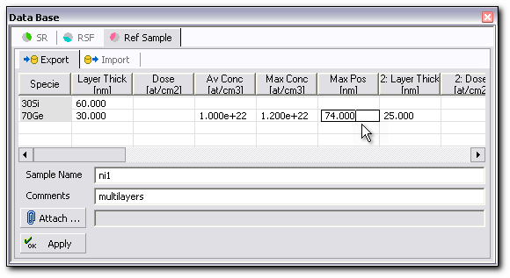
Figure 94. Data Base panel, Ref Sample/Export tab is used as the data entry.

An entry in this database can be made from any processed or raw data file and includes:
  - A processed file in binary format for future loading into a new Graph window. All detailed information about conditions of measurement and calibration parameters and results is contained there.
  - Known parameters of the reference sample, entered manually by user at the time of record creation:
- Layer thickness [nm].
- Dose of the implanted species [at/cm²].
- Average concentration Av Conc [at/cm³].
- Concentration in the maximum of distribution Max Conc [at/cm³].
- Position of the maximum of distribution Max Pos [nm].
All these parameters are stored for every specie of interest along with the Specie name. For a multilayered structure, the interface position and concentration of every layer is considered.
  - Comments.
  - Attached file. A file with any extension can be attached to the Reference sample database record. For example, it can be the generated Word or Data Summary report, obtained surface image, etc.
  - Analytical measurement parameters. Available parameters are given in the Table below.
  - The file name.
  - The sample name.
  - The time of measurement.

Procedure to make a Reference Sample database entry:
- Activate the Data Base panel.
- Activate the ‘Ref Sample’ tab and then the ‘Export’ tab at the top of the Data Base panel.
- Fill the known parameters of the reference sample in the proposed table.
- Make comments in the ‘Comments’ field if needed.
- Press the ‘Attach’ button to attach any file if needed. It is possible to attach a file with any extension. The ‘Attach File’ dialog box opens.
- Choose the file to be attached from the ‘Attach File’ dialog box.
- Press the ‘Apply’ button. The corresponding database entry is added to the database file. If the same database entry already exists then an information message appears.
Contents

Sample parameters and analytical parameters for the database.

Parameters | SR Query | SR Columns | RSF Query | RSF Columns | Ref Sample Query | Ref Sample Columns
Date of the entry | * | * | * | *
Date of the measurement |  |  |  |  | * | *
File name |  | * |  | * |  | *
Sample name |  |  |  |  | * | *
Matrix | * | * | * | * | * | *
Specie |  |  | * | * |  | *
Impact Energy | * | * | * | * |  | *
Mass Resolution | * | * | * | * |  | *
Vacuum | * | * | * | * |  | *
SR |  | * |  |  |  | *
Density |  | *
Unified SR |  | *
Sputter Yield |  | * |  | *
Normalized Sputter Yield |  |  |  | *
Concentration Calibration method |  |  |  | *
RSF |  |  |  |  |  | *
Normalized RSF |  |  |  | *
RSF normalized to matrix signal |  |  |  | *
Thickness |  |  |  |  |  | *
Dose |  |  |  |  |  | *
Average Concentration |  |  |  |  |  | *
Concentration in maximum |  |  |  |  |  | *
Maximum Position |  |  |  |  |  | *
Comments |  | * |  | * |  | *
Attached file |  |  |  |  |  | *
Ip |  | * |  | * |  | *
Raster |  | * |  | * |  | *
Sample high voltage |  | * |  | *
Dynamic Transfer DTOS |  | * |  | *
Field Aperture |  | * |  | *
Contrast Aperture |  | * |  | *
Entrance Slit |  | * |  | *
Energy window |  | * |  | *
Energy offset |  | * |  | *
Analytical area |  | * |  | *
EGate |  | * |  | *
Oxygen flooding |  | * |  | *
E Gun |  | * |  | *

SR/RSF Database Query
The database manager appears upon activation of the ‘Import’ tab. It allows a search to be performed using certain parameters which are selected in the query filter area. The database manager also allows access to the measurement conditions which are chosen in the ‘Columns’ menu. It is also possible to import calibration parameters to the Depth or Concentration calibration panels from the SR/RSF database.
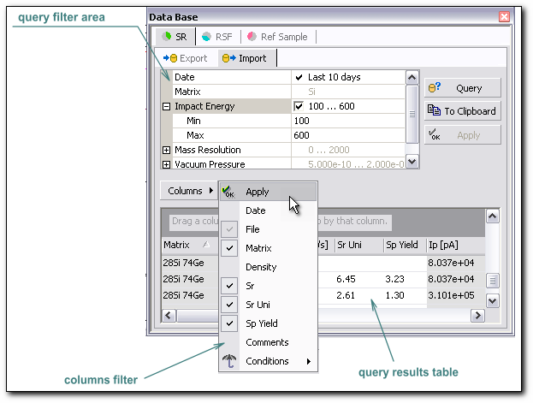
Figure 95. Data Base panel, SR/Import tab is used as database manager.

The database manager contains:
- Query filter area. Use it to choose the query criteria.
- Query results table. Indicates the query results.
- ‘Query’ button. Press it to start query execution.
- ‘To Clipboard’ button. Exports the ‘query results table’ to the Clipboard for insertion into an office application.
- ‘Apply’ button. It is used to import an obtained result which is presented in the ‘query results table’ to the Depth or Concentration calibration panel.
- ‘Columns’ button. Click this button to choose analytical conditions and calibration results which will be presented in the ‘query results table’.
- ‘Delete’ button. Deletes the selected database records. A confirmation box appears to confirm deletion.
The SR/RSF database query is performed using the following parameters:
- Date
- Matrix name
- Impact energy interval
- Mass resolution interval
- Vacuum pressure interval
If no parameter is selected, then the query is executed for all existing records.
The answer to a query for a one-element Matrix will consist of any isotope of this Matrix. For example, the result for a ‘Si’ query will be ‘28Si, 30Si, Si’, in other words, any combination of ‘Si’ with numbers. The answer to a query for a two or more element Matrix will consist of the composition of any isotopes of the Matrix components. For example, a query for 'SiGe' gives '28Si74Ge' and 'SiGe'. A query by Specie name works the same way.

To make a query by Matrix name do not put all the letters in caps; upon doing so, you will not have any response: a query for ‘SI’ will give nothing.

After query execution, the table at the bottom of the database manager is filled with the query results. The presentation of this table is defined by the ‘Columns’ button where the columns to be displayed can be chosen. The ‘Columns’ menu has the same appearance as the ‘Columns’ menu in the Data Summary panel.
The columns can be rearranged in the table by dragging them into desired position horizontally. The obtained results can be ordered in a selected column. The message ‘Sort by: column heading’ appears on the cursor over the column header. Besides, you can group the results by column name. The number of grouping levels is unrestricted.
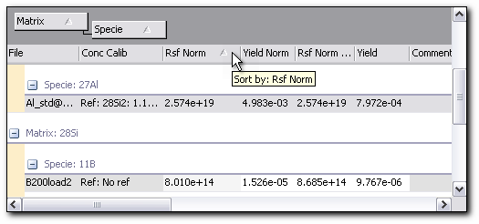
Figure 96. The sorted and grouped query results table.

To sort results in a column:
- Place cursor on the column header, press it. The small sign ‘sorted by…’ appears on its right.
- Release cursor.
- To change to the ascending or descending sorting order, simply click again on the column header.
To arrange column position:
- Place cursor on the column header, press it and drag the header horizontally into desired position.
- Two small red arrows appear to mark a possible header placement.
- Release cursor.
To group results:
- Place cursor on the column header, press it and drag the header into the area marked ‘Drag a column header here to group by that column’.
- Two small red arrows appear to mark a possible header placement.
- Release cursor.
- To ungroup the results, drag the column header again onto the table headers’ area.
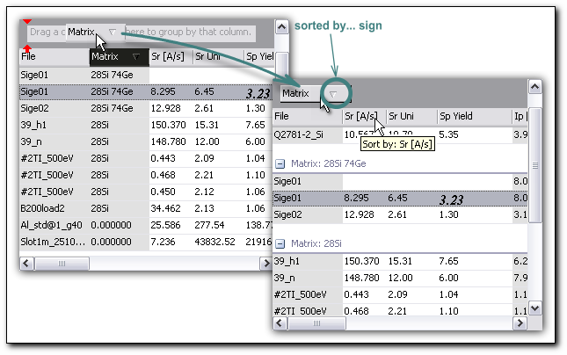
Figure 97. Sorting procedures for the query results table.
The fields with a white background contain information which can be used to perform the Depth or Concentration calibration. For the Depth calibration it is possible to choose the SR, Unified SR or SP Yield value from the SR database part and accomplish the calibration by pressing the Apply button. The database value will be put directly into the SR field on the Depth calibration panel. The SR known method will be applied. The SR will be put as it is, but upon choosing Unified SR or SP Yield, the SR will be recalculated according to the formulas of paragraph 7.1.1 with the use of the current file parameters.
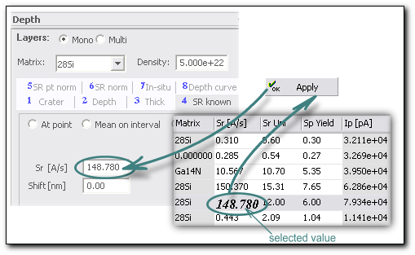
Figure 98. Applying the SR value stored in database.

Procedure to make a calibration with a SR value stored in the SR/RSF database:
- Click on a desired value with a white background. It can be SR, Unified SR or SP Yield. It becomes selected in bold italic font.
- Press the ‘Apply’ button. The recalculated SR value appears in the SR field of the SR known tab on the Depth calibration panel.
- Accomplish the Depth calibration.

Likewise, it is possible to employ RSF database values to accomplish the Concentration calibration. In this case the RSF normalized to natural abundance, RSF normalized to the matrix signal natural abundance, the Useful Yield or the Normalized Yield can be used. A chosen value - after recalculation according to the formulas of paragraph 7.1.2 - will be input into the RSF field on the Concentration calibration panel. The calibration method will be chosen automatically depending on the applied calibration method which is written in the database record.
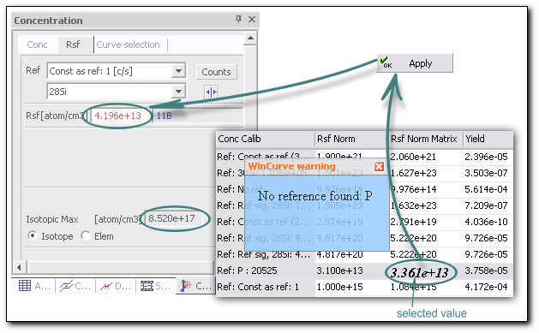
Figure 99. Applying the RSF value stored in database.

Procedure to make a calibration with a RSF value stored in the SR/RSF database:
- Click on a desired value with a white background. It can be RSF normalized to natural abundance, RSF normalized to the matrix signal natural abundance, Useful Yield or the Normalized Yield. The chosen value becomes selected in bold italic font.
- Press the ‘Apply’ button. A recalculated RSF value appears on the calibration panel. The consistency between the selected RSF value and the current Curve is controlled (reference signal or reference element) by WinCurve. If the data is not consistent a WinCurve warning is displayed. The warning message does not prohibit performing the calibration, but only reminds that the calibration parameters do not correspond exactly to the ones which have been applied for the Specie located in the database.
- Accomplish the Concentration calibration.

A warning message in blue appears if there is any irregularity and vanishes shortly after. To prevent its disappearance in order to read warning message, click on it.

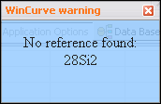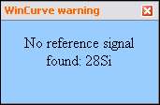
Figure 100. The warning messages appearing during the importing of the RSF value from database.
Contents

Reference Sample Database Query
The database manager for the Reference sample database contains two additional buttons in comparison with the SR/RSF database:
- ‘Open Graph’ button. Opens a new Graph window corresponding to the file name in the selected record. The name of this duplicate file is crv_filename_randomNumber.dp_rpc.
- ‘Open Attach’ button. Opens attached file if it exists.

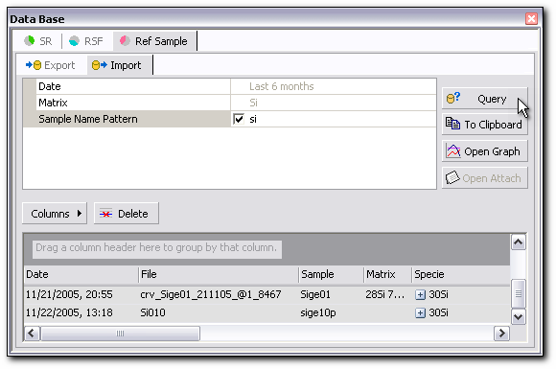
Figure 101. Data Base panel, Ref Sample/Import tab.

The reference sample database query is performed using the following parameters:
- Date
- Matrix name
- Sample name
If no parameter is selected, then the query is executed for all existing records.
The search for a Matrix name is performed in the same manner as in the SR/RSF database.
The search for a Sample name is performed according to a Sample name pattern: it is enough to enter any consecutive combination of letters and numbers of the sample name. For example, the result for a ‘si’ query will be any sample which name contains ‘si’ in the beginning, in the middle or in the end of the name. This query is not case sensitive.
The results can be sorted and grouped by parameters which can be applied to the whole file such as: file name, sample name, date of measurement, Matrix and measurement conditions.
If the database record has different species or layers, then it is possible to have the results in two kinds of presentation: with opened or collapsed species or layers. A small sign appears for an opened record, and for a collapsed record a small sign appears.

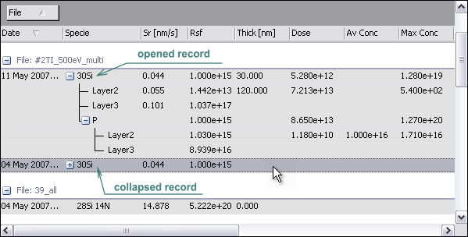
Figure 102. Grouping for the query results for the Reference Sample database part.
Contents

Utilities

Table of the File Types

file_name.dp | Raw data depth profile | file_name.dp_rpc | Processed depth profile
file_name.ls | Raw data line scan | file_name.ls_rpc | Processed line scan
file_name.ms | Raw data mass spectrum | file_name.ms_rpc | Processed mass spectrum
file_name.hr | Raw data high resolution | file_name.hr_rpc | Processed high resolution
file_name.br | Raw data bar graph | file_name.br_rpc | Processed bar graph
file_name.nrj | Raw data energy distribution | file_name.nrj_rpc | Processed energy distribution
file_name.dp_rpc_asc | ASCII depth profile | file_name.dp_rpc_txt | Text depth profile
file_name.ls_rpc_asc | ASCII line scan | file_name.ls_rpc_txt | Text line scan
file_name.ms_rpc_asc | ASCII mass spectrum | file_name.ms_rpc_txt | Text mass spectrum
file_name.hr_rpc_asc | ASCII high resolution | file_name.hr_rpc_txt | Text high resolution
file_name.br_rpc_asc | ASCII bar graph | file_name.br_rpc_txt | Text bar graph
file_name.nrj_rpc_asc | ASCII energy distribution | file_name.nrj_rpc_txt | Text energy distribution
file_name.dp_brcp | depth profile recipe file for batch processing | file_name.dt_sm | Data summary
file_name.ls_brcp | line scan recipe file for batch processing | file_name.bdt_sm | Batch processing data summary
file_name.ms_brcp | mass spectrum recipe file for batch processing | crv_SrRsf.db | SR/RSF database
file_name.hr_brcp | high resolution recipe file for batch processing | crv_Ref.db | Reference sample database
file_name.br_brcp | bar graph recipe file for batch processing
file_name.nrj_brcp | energy distribution recipe file for batch processing

Shortcuts
Ctrl + A | Add raw data or processed file to the active Graph window
Ctrl + O | Open raw data or processed file to the new Graph window
Ctrl + P | Print the active Graph
Ctrl + S | Save file corresponding the active Graph window
Ctrl + Shift + A | Open the ASCII Data panel
Ctrl + Shift + B | Open the Labels panel
Ctrl + Shift + C | Open the Concentration Calibration panel
Ctrl + Shift + D | Open the Depth Calibration panel
Ctrl + Shift + E | Open the Delete panel
Ctrl + Shift + H | Open the Analytical Conditions panel
Ctrl + Shift + M | Open Comments panel
Ctrl + Shift + N | Open Units panel
Ctrl + Shift + O | Open Copy panel
Ctrl + Shift + P | Open the Application Options panel
Ctrl + Shift + R | Open the Processing panel
Ctrl + Shift + S | Open the Species panel
Ctrl + Shift + T | Open the Table panel
Ctrl + Shift + M | Open Comments panel
Ctrl + Shift + U | Open Depth Curve panel
Ctrl + Shift + V | Open Curve Options panel
Ctrl + Shift + X | Open Axes panel
Ctrl + Shift + Y | Open Data Summary panel

Contents

